Learn about MiContact Center at UC San Diego
MiContact Center is an advanced Multimedia Contact platform offering agent applications, management applications and self-service applications. It operates on the Mitel communications system and presents full IP-based contact center capabilities.
MiContact Center offers solutions for departments of all sizes. MiCC supports multiple-site implementations, thereby enabling dispersed customer-service organizations to behave and be perceived as one single enterprise.
With MiContact Center any enterprise can improve their customer service through complete, up-to-date information about their staff instantly at hand, and quick response to customer requests. MiCC allows the user to successfully manage the customer experience center with real-time dashboards, historical reports, and business analytics.
The powerful suite of management tools in the MiContact Center solution provides continuous, detailed insights into the contact-center activity without adding complexity. The reporting, real-time viewing, networking, knowledge-base management, and configuration capabilities enable you to compare the use of different resources, and to analyze queue performance metrics and overall contact-center efficiency.

INTRODUCTION
Before you install MiCC Enterprise, please read through this document.

INSTALLATION PREPARATIONS
To make sure the appropriate hardware and software for a MiCC Enterprise system have been configured, please review the bullet points below. It is recommended that no applications are running when you perform an installation of MiCC Enterprise.
- You must have administration access on your PC in order to install the software.
- Must first be connected to campus network (via Ethernet cable on site or via VPN).
- Make sure to close out and save any applications before starting the install. It will prompt a restart when completed.

TYPICAL INSTALLATION
- From either the Windows or the Search icon, type \\solidus-a02 and press enter.
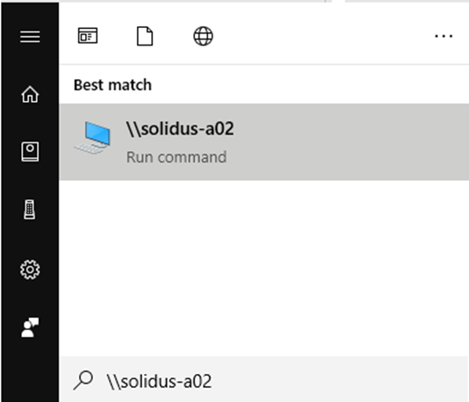
- Double click on NextCCClient.
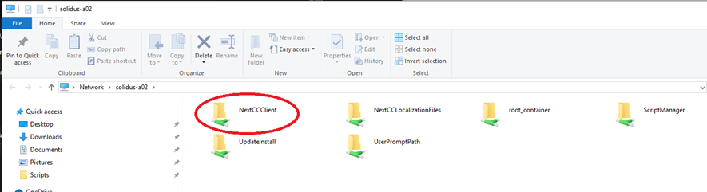
- Double click on Setup.exe.
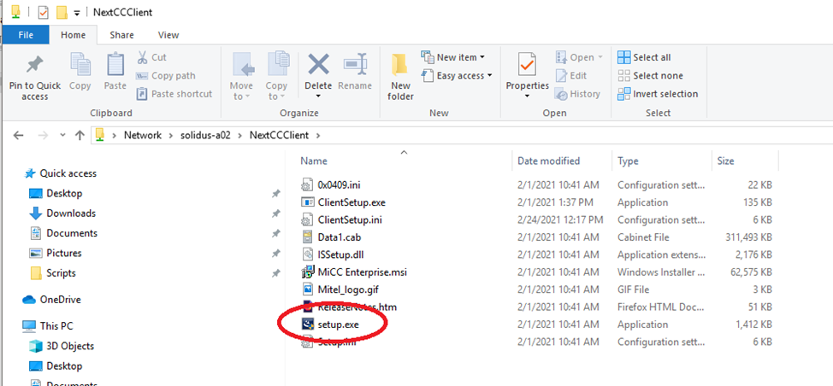

- When prompted click on the shield located on the computer task bar, choose Allow changes.

INSTALLSHIELD WIZARD
- InstallShield Wizard for MiCC will launch. The Welcome dialog for MiCC Enterprise appears. Follow the prompts as followed and click Next.

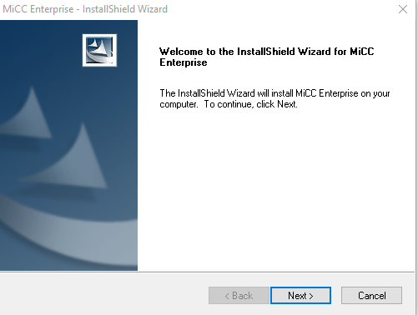

- The License Agreement dialog box appears. Accept the license agreement and click Next.
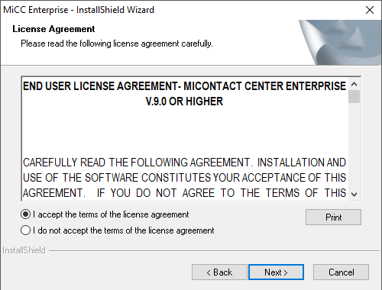

- The Customer Information dialog box appears. Keep the default information and click Next.
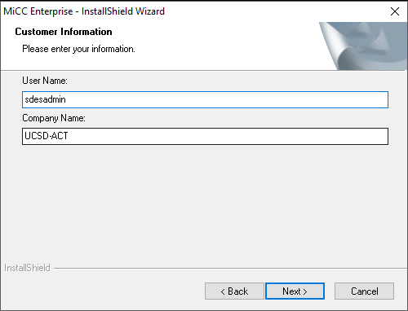

- The Setup Type dialog box will appear. In the Setup dialog box, select Custom and click Next. Program will be installed with most common options. Recommended for most users.
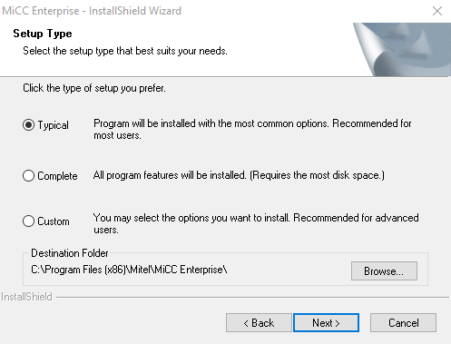

- The SQL Location dialog box appears. Keep the default location and port information as is and click Next.
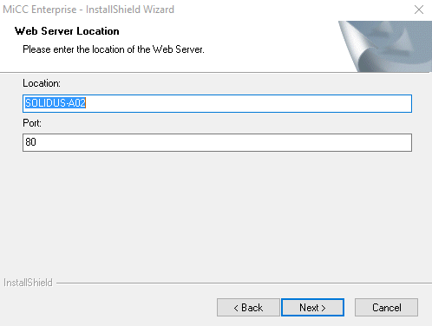

- The Select Features dialog box appears. Click the + next to Applications to expand the Applications menu.
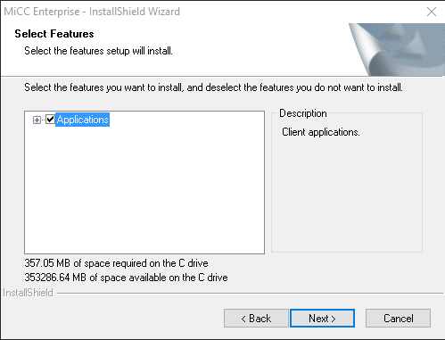

- Only choose Agent and ensure other options are unchecked.
*Note: If you are a group supervisor (super user) you may also want Report Manager and Information Manager checked.
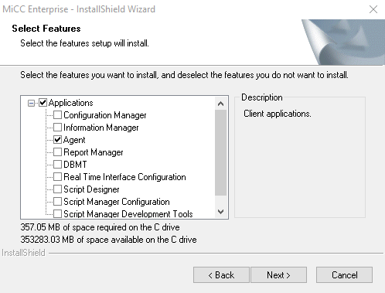

- The InstallShield Wizard Complete dialog box will appear. You have completed installation of MiCC Enterprise please click Finish.
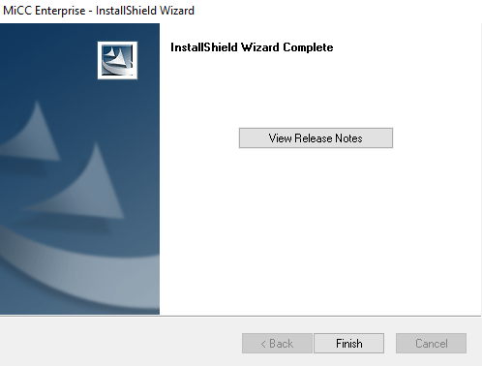

AGENT SERVICE OPEN INTERFACE

INTRODUCTION
MiCC is now installed and can be found in the Windows Menu under Mitel. The program to log into is Agent.

LAUNCHING AGENT
- Launch Agent under the Start Menu. Install any updates that are prompted;
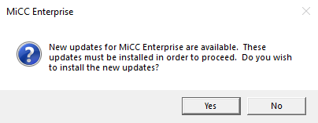

- Once the User Login window launches enter assigned Credentials and ensure Desktop Phone is selected for Extension Type.
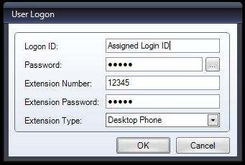

- MiCC Agent Window will launch.
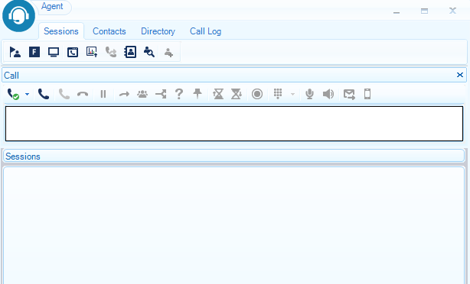

USING MiCONTACT CENTER AGENT

OVERVIEW
MiContact Center Agent is organized into tabs, including Sessions, Contacts, Directory and Call Log. When MiContact Center Agent starts up, it will display the last active tab. By default, the Sessions tab is displayed. The tables describe all icons in MiContact Center Agent. Grey icons indicate that the associated function is disabled in the current state.

