CMS Training: Create a Web Accessibility Web Page

These exercises will lead you through the basic functions in the campus CMS: creating a folder and page, pasting in and editing content, adding an image, and publishing

CMS stands for Content Management System. At UC San Diego it refers to Cascade CMS a product from Hannon Hill.

Once you’ve completed the exercises below, and have published your page to the staged Sandbox site, email us so we can look over your work. We’ll contact you about any issues or problems and answer any questions you might have. Once that is complete, we will provision you to your own site so you can begin working in the CMS.

You will complete this exercise in the Sandbox training site. If you don’t have access yet, submit a ticket by emailing wts@ucsd.edu.

Once you have access, follow the steps below to begin your training.

Note: This training will cover basic functions. You will see options in the CMS that are not discussed in this training. Once you are comfortable with the functions covered in the training, you can explore additional documentation at: https://blink.ucsd.edu/technology/websites/training/index.html
Contents
CMS Training: Create a Web Accessibility Web Page 1
Section 1: Log in to the CMS 2
Section 2: Create a folder for your page 2
Section 3: Create your page 6
3.1 Template, Name and Initial Fields (Metadata) 6
3.2 Enter Text 9
3.3 Headings 12
3.4 Additional Text Formatting 14
3.5 Adding Links 15
3.6 Adding an Image 20
3.7 Adding a Module 22
Section 4: Preview Draft, Submit, Publish 25
Section 5: Review and Turn in Your Work 29

Section 1: Log in to the CMS

- In your browser (recommended browsers), go to https://cms.ucsd.edu and sign in using your business systems (SSO not AD) account.
- In the upper-left corner click in the Go to a Site box and choose Sandbox from the slide-out menu.
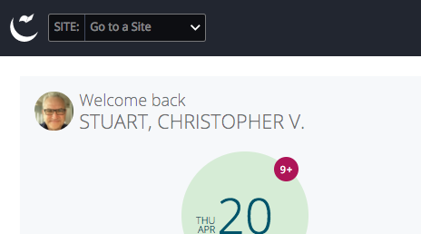

Section 2: Create a folder for your page

- As you move around the CMS, you should be aware of the difference between navigating to assets (folders, pages, files, etc.) and selecting them.

In the left navigation window, click on the training folder. You should see a number of sub-folder appear under training. These folders belong to others who have taken the CMS training. You are navigating the site, but you haven’t selected anything yet. Note that nothing in the main window has changed.

To select the training folder, hover your mouse over the training folder and a > symbol will appear to the right of the folder name. Click on the > symbol. You have now selected that folder and will see the contents of that folder in the main window – not just in the left window.
Important: Make sure you have selected the training folder by looking at the main window. You should see “Folder: CMS Training Pages” at the top, followed by the breadcrumbs: “Sandbox / training”
If you do not see this, then you have not actually selected the training folder. Don’t click on training (which is just navigating around the site). You need to click on the > symbol.

Selecting the training folder will let you place your new folder inside the training folder (otherwise your folder will be in the wrong location). Correct locations are very important in the CMS because the location in the CMS corresponds to the URL (web address) on the live site.

- Click on the Add Content button at the top of the window and select Folder.
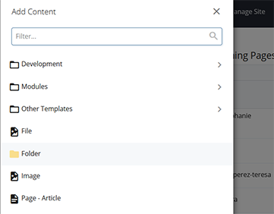

- Replace “base-folder” in the Folder Name field with yourlastname-yourfirstname (for example, doe-jane).

Important: Notice the Folder Name is all lowercase with no spaces. Folder and Page Names should always follow this convention as it’s what appears in the URL. Failure to do so can result in pages not being found and an inability to redirect traffic from the bad URLs.

- Learn more about Folder and Page Names: https://blink.ucsd.edu/technology/websites/training/new-page/system-name.html
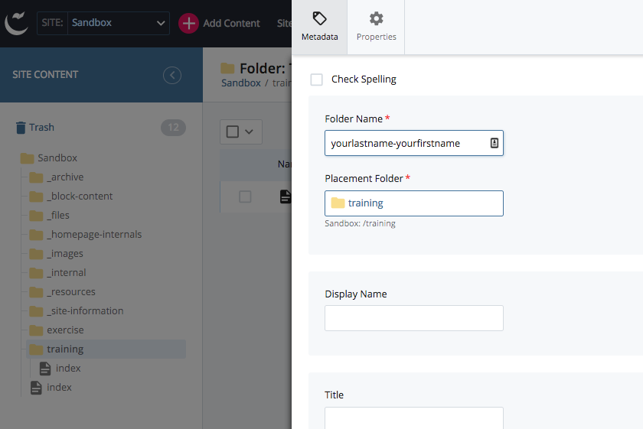

Click the blue Submit button in the top right.

A Spell Check screen may pop up. If it does, click the blue button with the check mark to close it.

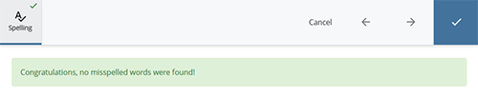
- Click on the Edit button in the top right of the screen:
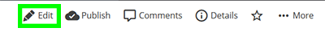
Your screen should now look something like this:
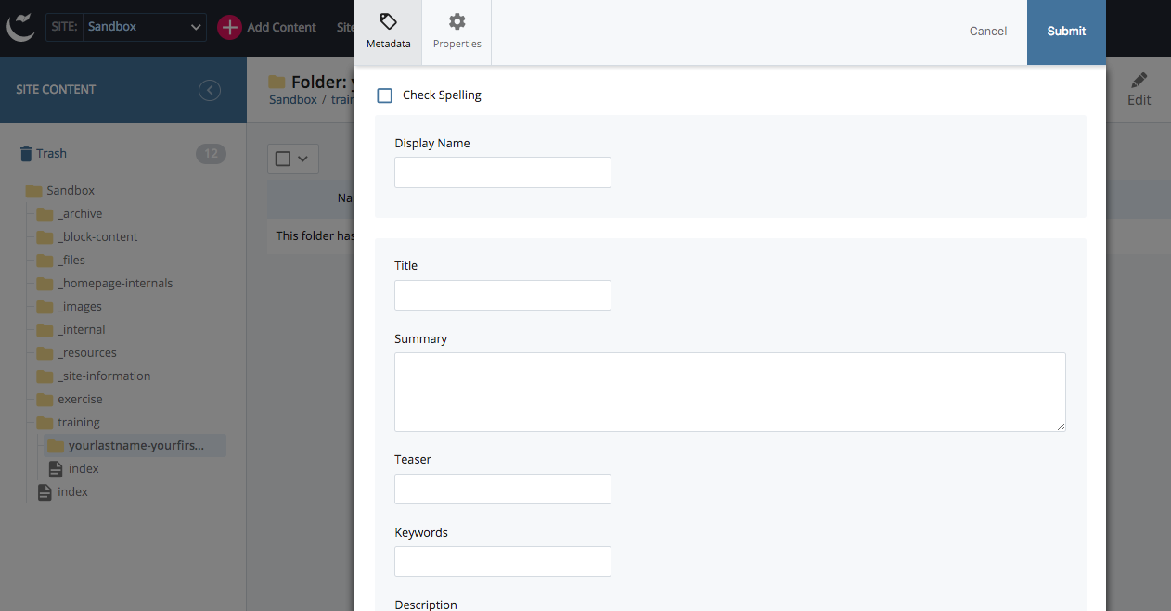
- Fill in the metadata fields:
  - Display Name: Enter your name (for example, Jane Doe). This will show up in the site navigation (breadcrumbs and left navigation).
  - Title: Enter the same name.
  - Summary: Type “This is my first page for the campus CMS training site.”
Note that uppercase letters and spaces are permitted in all three fields here.

- Learn more about these fields: https://blink.ucsd.edu/technology/websites/training/new-page/metadata.html

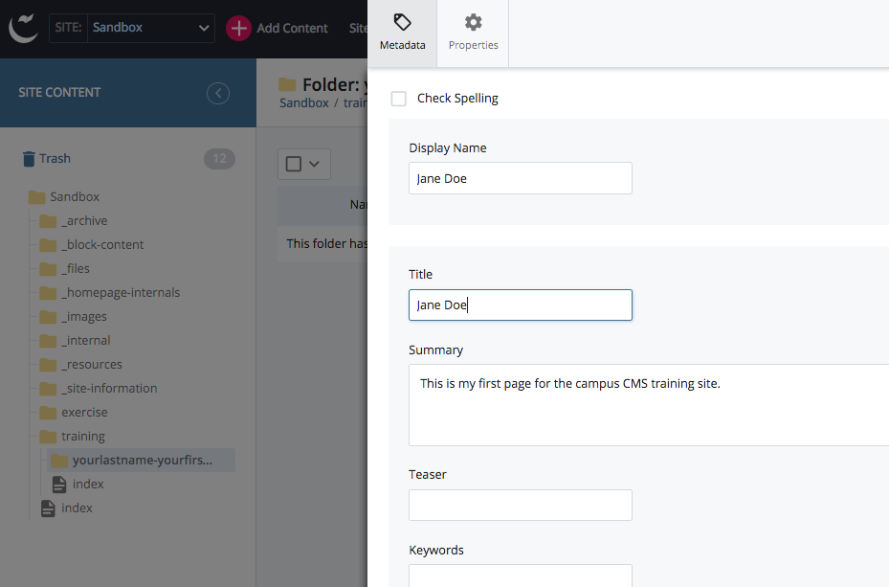

Click the Submit button in the top right.

You may get the Spell Check pop up again. Correct as appropriate and click the checkbox when finished. You may get a pop-up dialog box that says something like:

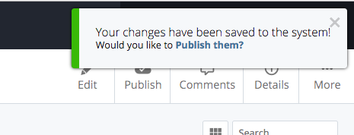
If you do, click on the X to get rid of it for now because we’re not quite ready to publish.

Section 3: Create your page

3.1 Template, Name and Initial Fields (Metadata)

- Click on the Add Content button, scroll down and select Page – Article. (On older sites this is called Page - Two Column.)

The other options represent other resources like folders, files or images or other page templates. Page – Article is the most frequently used template. Different sites will have different templates available to them.
- Learn more about templates: https://blink.ucsd.edu/technology/websites/training/new-page/templates/index.html
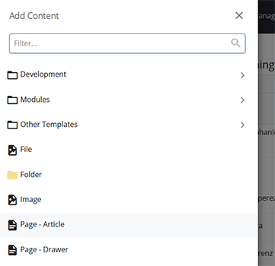
- The new Page – Article template will appear.

- Type into the fields as shown here (remove the text automatically generated by the template):

Page Name: index (Note: Page names should conform to the no uppercase, no spaces convention as this will be part of the site URL. If you capitalize ‘index’ your page will not publish properly.)
Display Name: Web Accessibility Page
Title: Your Name’s Web Accessibility Page (for example: Jane Doe’s Web Accessibility Page)
Summary: This is my first CMS page.
Author: Type in your name, for example: Jane Doe

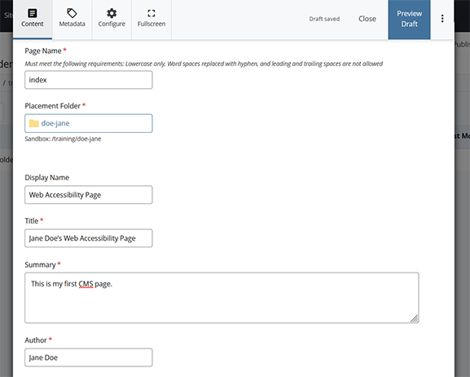
Notice this Page Name is “index” because every folder in the CMS has to have one “home page” named “index.” This automatically becomes the landing page for the folder.

The two most important things when creating a new page are:
- Every folder must have an index page (the system name is all lowercase ‘index’).
- Every system name (page name) should be all lowercase with dashes instead of spaces.

- Learn more about page names and how they should be formatted: https://blink.ucsd.edu/technology/websites/training/new-page/system-name.html

Now click on the Preview Draft button: 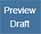

You should now be looking at a screen like this:

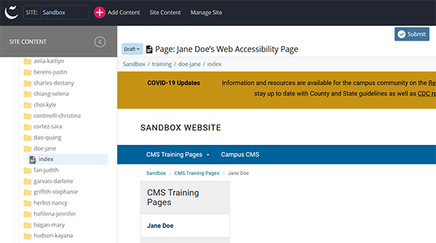

You may get a pop-up dialog box asking if you want to Submit the draft. You can click submit there or click on the Submit button in the top right. You’ll get a dialog box like this:

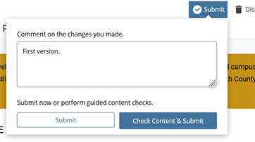

You can enter text in the Comment field if you want. You’ll see something by default, such as “First version.” Click on the Submit button. (You could also click on the Check Content & Submit button. This includes spell-check and link checker, which you can explore on your own.)

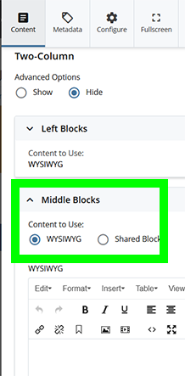
3.2 Enter Text
- Click on the Edit button again: 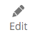
Scroll down so you can see the WYSIWYG (What You See is What You Get) editor in the Middle Blocks section.
(The Left Blocks section is just above the Middle Blocks section, and applies to the page area underneath the left navigation buttons. Make sure you are not entering text in the Left Blocks section. Different page templates will have different blocks in them. Pay attention to the names of the blocks so you know what section of the page you are editing.)
- Under Middle Blocks, there is a heading called Content to Use. Make sure that the button for WYSIWYG is selected.

Copy and paste the plain text below into the WYSIWYG editor.
---- copy and paste text below this line ---
My Web Accessibility Page
Importance of Web Accessibility
The University of California Office of the President is committed to electronic accessibility. This commitment includes creating sites and pages here at UC San Diego that are accessible to all users.
The Americans with Disabilities Act (ADA) requires that public spaces are accessible to all regardless of disability. Recent lawsuits have demonstrated that websites are treated like a public space for this purpose.
In order to comply with the ADA, the University of California follows an international set of Web standards: the Web Content Accessibility Guidelines (WCAG) 2.0.
Screen Readers
Imagine being a user with a visual impairment. If you could not see this page, you would need a screen reader to help navigate through the content. Link to an example of a screen reader in use.
Just as buildings need to be accessible to individuals in wheelchairs to be compliant with the ADA, websites need to be accessible to individuals that use screen readers.
As mentioned in the video clip, not all content is equally useful to a screen reader program. Some things you can do to help screen readers include:
Using headings
Having informative link text
Opening links in the same window (i.e. don’t open a new window)
Including descriptive alt text for images
Using standardized site organization
The campus CMS helps you manage a site that has a standardized organization and navigation across UC San Diego site. It also takes care of some of the behind the scenes requirements so you don’t have to. But you are responsible for making sure the content of your page is accessible.
Additional Benefits
Creating more accessible content also creates more usable content.
Headings help users scan the page and find what they are looking for. Informative link text makes the page easier to read. Keeping links in the same window allows users to use the back button on their browser – a common behavior that is disrupted if you open links in new windows.
Accessible pages can see improvements in search engine results.
Headings are an important component for search engine optimization, so organizing your content with headings simultaneously boosts your search. Images of text are invisible to search engines. By having alt text that contains all the information of the image, you allow search engines to include this content as a search factor.
Resources
University of California
UCOP Electronic Accessibility
Information Technology Accessibility Policy (PDF)
Electronic Accessibility in the News
https://www.nytimes.com/2017/10/11/nyregion/college-websites-disabled.html
https://www.d.umn.edu/~lcarlson/atteam/lawsuits.html
Questions? Contact wts@ucsd.edu between 9AM and 5PM
--- copy and paste above this line ---
You should see the plain text in the WYSIWYG editor now and can now start formatting the text.

Writing and formatting text for the Web is different than for print. Expect to edit and reformat text that originally comes from print (Word files, PDF flyers, etc.) or other forms (like presentation slides).

- Learn more about writing for the Web: https://blink.ucsd.edu/technology/websites/training/writing/index.html

Even simple copy-pasting from a word processing program into the CMS doesn’t guarantee the content will look the same. Word processors can have hidden formatting that results in extra spacing or text formatting. Don’t paste in images. We’ll learn how to add an image later.

Always review how your content looks in the CMS. You shouldn’t be able to click on the blank space between lines of text. In this exercise, if you have any extra blank lines between the lines of text, put your cursor on the line and use backspace to delete it. Your pasted text should end up looking like this:

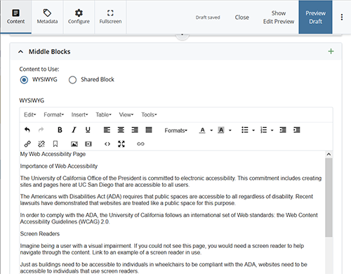

Now we need to format this text for the web.

3.3 Headings
- Every page in the CMS should have exactly one H1 or “Heading 1” line that acts as the title of the page. This heading should concisely describe the page content. The heading acts as the most important keyword or key phrase to improve Search Engine Optimization (SEO).

Select the words “My Web Accessibility Page” and then click on the Format drop-down menu in the WYSIWYG tools area choose Headings and select Heading 1 (also available from upper menu: Format->Formats->Headings->Heading 1):

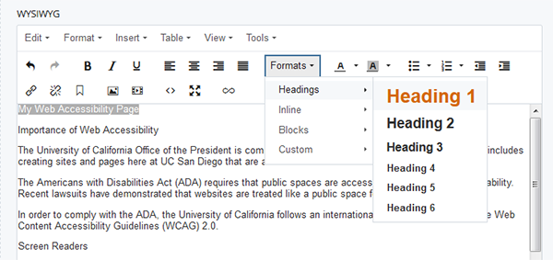

After clicking on Heading 1 you should now see the words “My Web Accessibility Page” formatted like this:

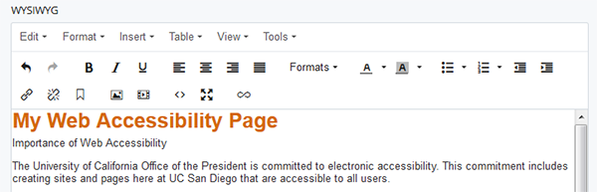
Headings will automatically create spacing around them. Do not use the enter key to create additional lines of space under a heading. This will create empty heading tags that are bad for search engines and screen readers.

- Page titles should be unique in a given site. Since many users will be making a training page, you should distinguish your page from theirs. Change the “My” in the newly formatted title to “Your Name’s.” This will help us know that we are looking at your page. Unique page titles also help produce better search results.

If you will be editing pages in Blink, the Heading 1 of the page will be automatically generated from the “Title” field. Do not add an additional Heading 1.

- Learn more about working specifically in Blink: https://blink.ucsd.edu/technology/websites/training/start/access/blink.html

- Now let’s format the H2 headings that designate the subheadings on the page. These subheadings are important because they improve seach results and improving readability by breaking up large blocks of text.
First, select the words “Importance of Web Accessibility.” Then pop open the drop-down Formats menu in the tools area and select “Heading 2.” You may experience odd line adjustments, so experiment with adding or removing line returns until the content looks the way you want.

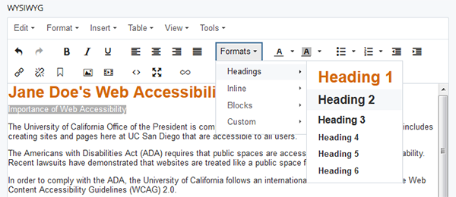
It should now look like this:

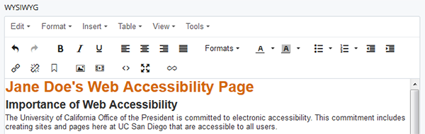
Do the same (format as Heading 2) for the lines that have the words:
Screen Readers
Additional Benefits
Resources
Sometimes you will want to create subheadings to further organize your content. Under resources, there are two sub-topics:

University of California
Electronic Accessibility in the News

Select each of these and format them as Heading 3. You should never skip heading levels as this can interfere with search results.

- Learn more about headings: https://blink.ucsd.edu/technology/websites/training/edit/headings.html

3.4 Additional Text Formatting
- Now we’re going to turn the list of things you can do to help screen readers into a bulleted list. Select the list of actions:

Using headings
Having informative link text
Opening links in the same window (i.e. don’t open a new window)
Including descriptive alt text for images
Using standardized site organization

and click on the Bullet list 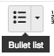 button in the tools area. This will format the list but, again, you may need to play with line returns in order to get it to format correctly. (This is due to possible hidden formatting that was copied when you copy and pasted the text.)
If you’re familiar with HTML, you can edit the HTML code directly by clicking the code button:.
Your content should now look something like this:

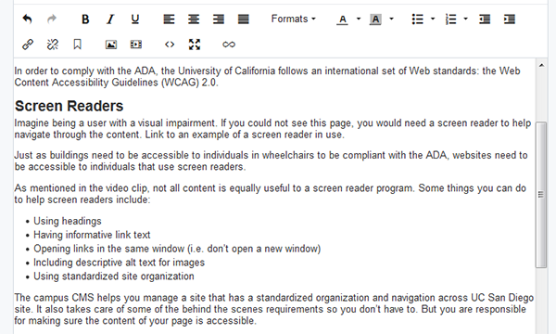

- Now you are going to make an edit based on the UC San Diego Style Guide. Our style mostly follows The Associated Press (AP) Stylebook, but includes entries unique to UC San Diego. Follow the style guide to ensure consistency and professionality throughout UC San Diego sites.

Go to the style guide at: https://blink.ucsd.edu/technology/websites/training/writing/styleguide/index.html (We recommend that you bookmark this page for future reference.)

Go to the entry for “times of day.” Note how the style guide uses “a.m.” and “p.m.” with a space after the numeral. Our current page uses “AM” and “PM” with no space (see the last text on the page). Edit your page to follow UC San Diego style for times of day. Following the style guide will also prevent these times from appearing in the CMS spell check.

3.5 Adding Links

- Let’s add some links. Always use text that makes it clear where a link will take the user. Don’t use text like “click here” (it isn’t accessible).

- Learn more about best practices for links: https://blink.ucsd.edu/technology/websites/training/edit/links.html

There are two kinds of links in the CMS: internal and external.

Internal links are links that go to other resources (usually pages or files) in your CMS site. Normally, if a page is renamed or moved, it will break links to that page (because the location in the CMS is what creates the URL, or web address). If the link is an internal link, the CMS can track these links and repair them when the page gets republished (this is one reason Blink is republished every weekend). Always use internal links for links within your own site.

External links are for links to resources outside of your site.

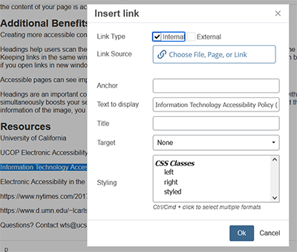
- We’ll start with an internal link to a file.

Use your mouse to select the words “Information Technology Accessibility Policy (PDF)” in the “Resources” section (note that we want to include the “(PDF)” in the link text). Then click on the chain link icon to pop up the Insert/edit link dialog box:

The box next to Internal will be checked by default.

Next to Link Source, Click on the Choose File, Page, or Link box to open the file chooser.

Click on Browse
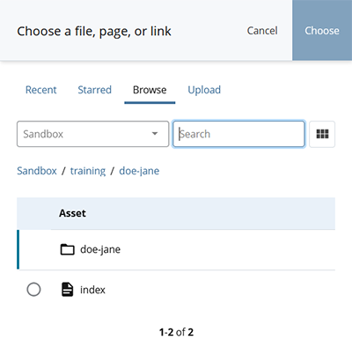
Now you are going to navigate to and select a file within the CMS.

You can see your current location from the breadcrumb trail: Sandbox / training / yourlastname-yourfirstname. The breadcrumb trail is made of links to folders in this site. Click on Sandbox to go to the top level of the site.

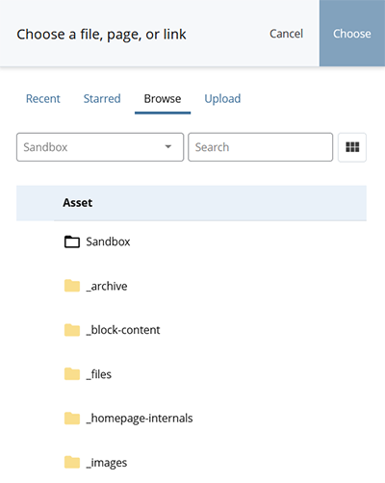

From here you can scroll down and see the next level of folders in the site. The folder you are in is white (like Sandbox) – this folder is open. Other folders are closed, and are yellow. To open a folder, click on the folder name.

Open the folder named ‘_files’ by clicking on the folder name.

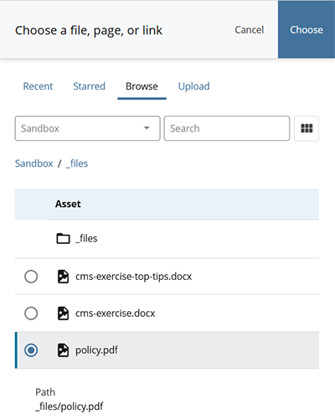
There are multiple files in this folder, but we want the one named ‘policy.pdf’ Click on the radio button next to ‘policy.pdf’ to select it.

Click Choose in the upper right corner.

You will return to the Insert/edit link window. Click OK

You will see that the text for ‘Information Technology Accessibility Policy (PDF)’ is a light blue and if you hover your mouse over it, it will become underlined. You have added the link!
- Learn more about the file chooser: http://blink.ucsd.edu/technology/websites/training/edit/file-chooser.html

This example was a link to a file. You can also create an internal link to another page.

- Add an internal link to the campus CMS page in the Sandbox site. Follow the steps above (number 19) with the following differences:

Find the text “campus CMS” on your page (you can use ctrl+f in most browsers). Highlight it and click the link button to open the file chooser. This time, navigate to the page Sandbox/cms/index and add the link. Click Choose.

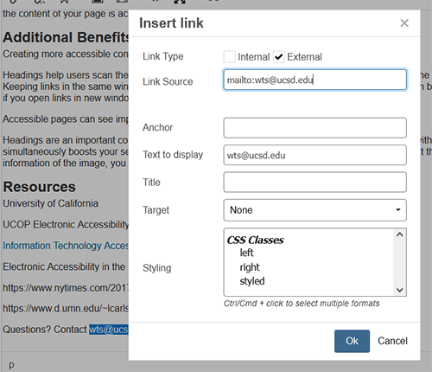
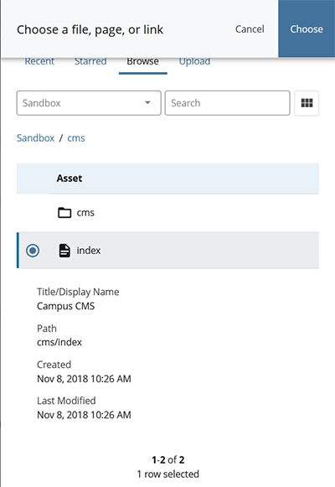
- Now we’ll add two kinds of external links.

First, let’s create an email link. Select the text “wts@ucsd.edu” towards the end of the text content.
Then click on the chain link icon and click the external link checkbox. Type “mailto:wts@ucsd.edu” into the Link field (remove the pre-filled http://).

Make sure you include ‘mailto:’ for email links.

Click the OK button. You’ll see the email address has automatically formatted as a link.
- External page:

Select the words “Web Content Accessibility Guidelines (WCAG) 2.0” in the third paragraph and then click on the chain link icon to pop up the insert link dialog box.

Click the checkbox next to “External.”

In the Link field, type or copy-paste the URL: https://www.w3.org/TR/2008/REC-WCAG20-20081211/ (replace the pre-filled https://)

Note: If you copy and paste a link from a Word or similar document, be sure to double check for and remove any hidden spaces at the beginning or end of the link. They will break the link.
Click OK to finish the link.

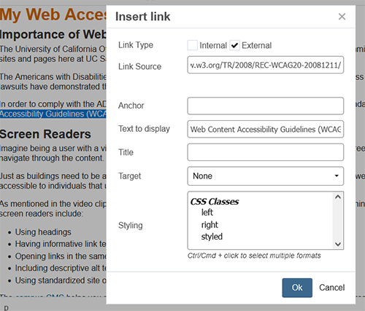

Repeat this process for the following text and links:

“screen reader in use” https://www.youtube.com/watch?v=q_ATY9gimOM
“UCOP Electronic Accessibility” https://www.ucop.edu/electronic-accessibility/

- Sometimes you’ll have text that is a URL. Generally, these should be converted into readable link text to make them easier to scan and easier for screen reader users to listen to. It is much easier to read and hear something like “New York Times article” than “https://www.nytimes.com/2017/10/11/nyregion/college-websites-disabled.html.”

In the WYSIWYG, select the text https://www.nytimes.com/2017/10/11/nyregion/college-websites-disabled.html

Copy the link text (Ctrl-C)
With the text still selected (you may need to select it again), click on the chain link icon to pop up the insert link dialog box.

Click the checkbox next to “External.” Paste the copied URL into the Link field.

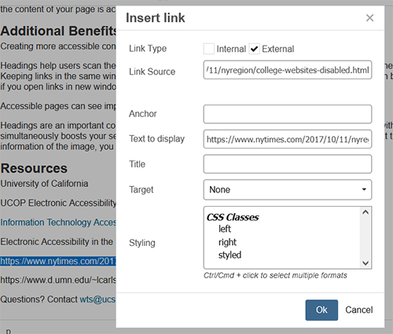

The Text to Display field also has the URL. Edit this field to a readable phrase that lets the user know where the link is leading to. This could be the article title, or a short description. Do not use any variations of ‘click here.’ ‘Click here’ is not informative and it is not accessable.

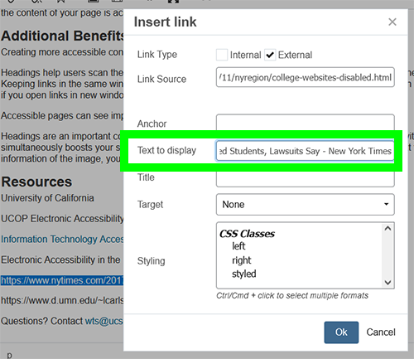
Click OK to finish the link.

Double check that the link text is readable and not a URL.

Repeat this process for https://www.d.umn.edu/~lcarlson/atteam/lawsuits.html

3.6 Adding an Image

- Now we’ll add an image. Position your cursor just after the Importance of Web Accessibility line in the content and click on the Insert/Edit Image icon in the tools area. You should see the insert/edit image dialog box:
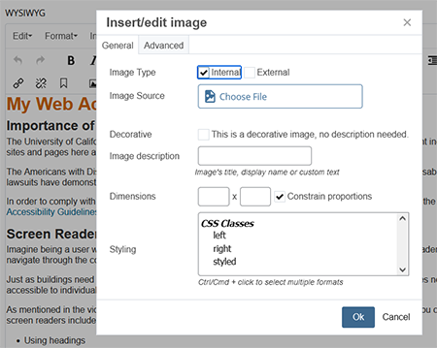
Next to Image Source, click on the Choose File button to open the file chooser (just like for other internal links). You can choose a recently viewed image, or a starred image (if you previously starred one), or browse to an image, or upload an image.

- Learn more about these options for the file chooser: https://blink.ucsd.edu/technology/websites/training/edit/file-chooser.html

For this exercise, click on the Browse tab.

In the breadcrumbs list ( Sandbox / training /yourlastname-yourfirstname ) click on Sandbox to navigate to the root folder.

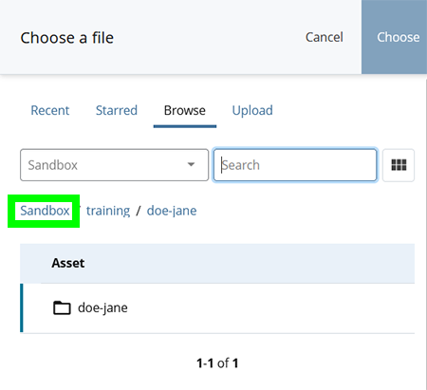
Open the _images folder and find the “library-doors.jpg” image. Select the image by clicking on the radio button.

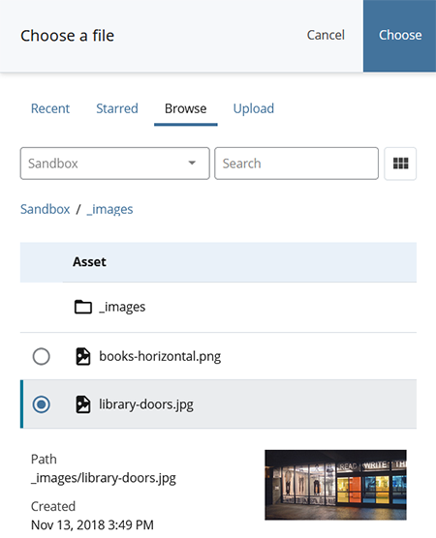
Click on the Choose button.
You should now be back at the dialog box. Type the words “Geisel Library entrance” into the Image description field. You must always add an image description for accessibility reasons.

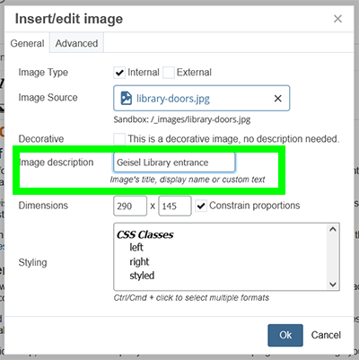
Now click the Ok button.
- You should now see the image in the content, but we still need to make sure the text flows around it properly. Click on the image in the WYSIWYG to select it. Click the Insert/Edit Image icon . In the bottom of the dialog box, select Right under CSS Classes. Click Ok. The image will now be positioned to the right of the text.
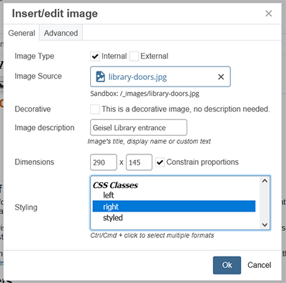

- Learn more about working with images: https://blink.ucsd.edu/technology/websites/training/edit/images/index.html

3.7 Adding a Module

- Finally, we’ll add a module. Modules are fairly new additions to the CMS and are only available in sites that have been upgraded to Version 5 templates. You can see if your site is upgraded to Version 5 by checking https://department.ucsd.edu/about/client-list.html
Somewhat like an image, modules are items that are separate from pages, but can be added to a page. A single module (or image) can be used by multiple pages. Unlike images, modules are designed in the CMS. For this exercise, we will just add an existing module to your page. To learn more about modules, including the different types and how to create them, see https://department.ucsd.edu/modules/index.html
Modules don’t get added to the WYSIWYG like images do. Instead, each module needs to be in a separate block. So far, you have been adding content to a single Middle Block. Now let’s add a second Middle Block.

- Scroll up past the top of your WYSIWYG window until you can see the section called Middle Blocks. Add a new Middle Blocks section by clicking the green + to the right of Middle Blocks.

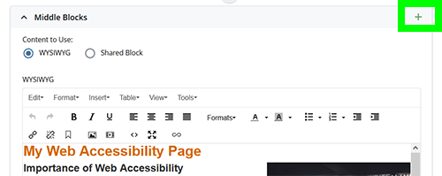

After you add the Middle Blocks section, some new information will appear next to the green + . You can see that there are two Middle Blocks and you can use the arrows to reorder them, or the red X to remove a Middle Block.

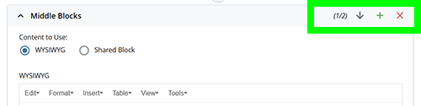

- Scroll down to the second Middle Blocks section (where the WYSIWYG is empty).
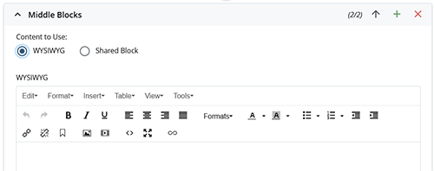
Under Content to Use: select Shared Block.
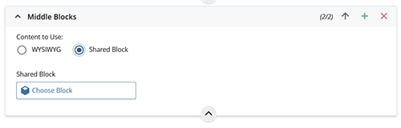
- The WYSIWYG is now replaced with a file chooser. Use the File chooser to select the shared block located at “_modules/top-tips-cta”
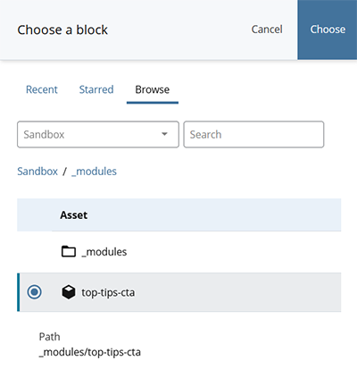
This works just like navigating to an internal link. Go to the Browse tab. Click on “Sandbox” in the breadcrumbs to get to the top folder of the site. Then click on the _modules folder. Then click on top-tips-cta. Then click Choose.

Now we are ready to see what the module (and the overall page) looks like.

Section 4: Preview Draft, Submit, Publish
- You’ve now put in all the content and formatted it the way you want, so you’re ready to save your work. You can save as often as you’d like (the CMS will auto-save your work as a draft). For this exercise, we’ve waited till this step so we’ll just do it once.
Click on the Preview Draft button:
You may notice a pop-up box at the bottom of the screen letting you know that your draft has been saved.
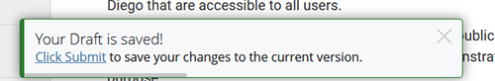
Your draft page should now look something like this:
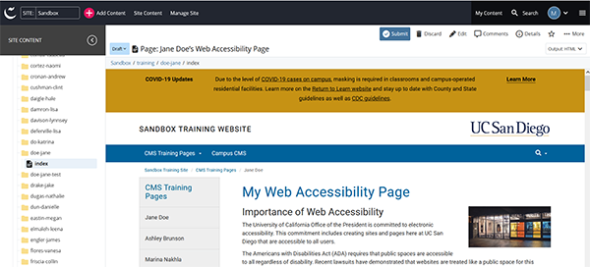
A draft is only visible to your account in the CMS. Before you can publish a page, you must Submit it. Submitting a page will also make it visible to other users in the CMS.

- Click on Submit. A dialog box will appear. You can add comments on what you have changed (optional, but useful if multiple people are working on the same page). Click the white Submit button to Submit your work to the CMS or click Check Content & Submit to have the CMS check your spelling and links first.
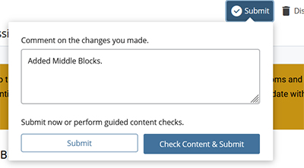
For this exercise, you can just click on the white Submit button.
You may see a pop-up at the bottom of the page confirming the submission and asking if you want to publish your page. We’ll take care of publishing later, after we make a few more changes.
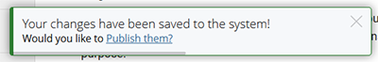
A summary of these three actions:

Preview Draft will show you what your page looks like and saves the page to your account
Submit will save your changes to the CMS as a whole, which lets other CMS users see it
Publish is the interface between the CMS and the live site. Publishing lets the general public see your site.

Make sure to scroll down to the bottom and see what the module you added looks like.

- Learn more about V5 sites:
https://blink.ucsd.edu/technology/websites/cms/version-5.html
- Learn more about modules:
https://blink.ucsd.edu/technology/websites/training/new-page/templates/general-cms/v5/modules/index.html

- Now that you can see how your page looks, you should see if there are any improvements you can make so the page content is easier to scan. Find where you can add the following (these are not marked in the jane-doe example page, you need to use your judgement):
  - Two places where a subheading would be useful (section 3.3, page 12; you may need to reword the text)
  - Two places where a bulleted list would be helpful (section 3.4, page 14)

You will need to return to the Edit screen (section 3.2, page 11) and then Preview Draft and Submit again.

- Publishing is the interface between the CMS and the live site. Changes you make in the CMS can’t be seen outside of the CMS until you publish them.
Click on the Publish button
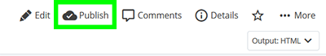

The publish page dialog box will open. The first time you open this, you may not see the publish setting. Click on View Publish Settings to expand the settings.

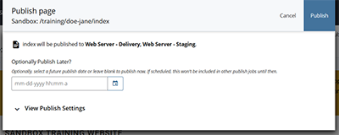
You should now see an expanded dialog box with both Delivery and Staging destinations checked. By default you’ll publish to the Delivery (live) site as well as the staged site. If you just want to publish to the staged site, un-check the Delivery checkbox.

In this case, we are only publishing to stage. Publishing to stage is useful when you want someone to review your content before making it live. Users will need to be on the UCSD network or using the “Group: 2-Step Secured – allthruucsd” VPN setting to see a page published to stage.

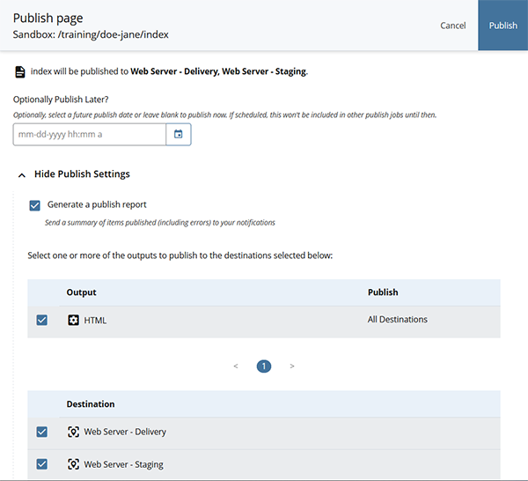
Uncheck Delivery so you don’t publish your page live for the whole world to see.
Click the Publish button in the top right:
A dialog box will appear asking if you want to view the Publish queue. This will take you to a queue of jobs being published from the CMS. You can look to see when your job publishes (individual pages will usually publish quickly, large folders will take more time), but you’ll need to remember to navigate back to the page you’re working on to make any further edits.

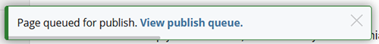

- Learn more about publishing: https://blink.ucsd.edu/technology/websites/training/publishing/index.html

Section 5: Review and Turn in Your Work
- The last step is to check your published work. It is important to always check your published work because some formatting may display differently in the CMS than on the published page.
Pages can be published either to delivery (live on the web) or to stage (available only to those on the UCSD network). Since you published your page to stage, you need to make sure you are on the UCSD network. If you are off campus or on part of campus that uses a different network, you will need to connect using VPN.
- Important: When connecting via VPN, make sure to install the VPN client (instead of using web access) and choose “Group: 2-Step Secured – alltruucsd.”
Once you are on the UCSD network, open a new browser window and go to: http://stage-sandbox.ucsd.edu/training/yourlastname-yourfirstname. Here’s the example we created: http://stage-sandbox.ucsd.edu/training/doe-jane/
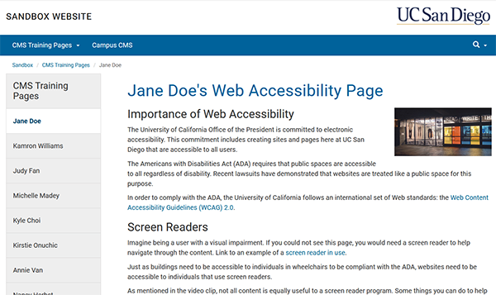
If your page isn’t publishing correctly, check that:
- Your page is named ‘index’ with no capitalization and no trailing space.
- Your folder is named in the format ‘yourlastname-yourfirstname’ with no capitalization or spaces.
- Your folder is located inside the ‘training’ folder.

To fix (a) or (b), see the instructions for changing a system name and republish.
To fix (c), you will need to move your folder and then republish.

- Request a review. After you have checked your work and are confident it is properly formatted, email wts@ucsd.edu to review your work.

What we’ll be especially looking for:
- Proper headings (you can compare against http://stage-sandbox.ucsd.edu/training/doe-jane/, but remember that you should have two more headings than this page – see step 31)
- Links working properly (click your links and make sure that they work)
- Image location and alt text/ description
- Bullet, link and time formatting (you should also have two more bulleted lists than the example – see step 31)

Include in your email:

  - Your name
  - The full URL of your staged page (just copy it from the browser)
Do not send your link from the CMS. We need to check that your page was published. Your URL should start with stage-sandbox.ucsd.edu… not cms.ucsd.edu…)
  - The CMS site(s) you are requesting access to.
    - If you are requesting access to Blink or TritonLink, you need to specify the second level folder(s) you need access to (i.e. blink.ucsd.edu/technology or blink.ucsd.edu/sponsor). Because these sites are so large, access is assigned by these subfolders.

