Create an Article Page:
I’m Going to Disney World!

Follow these instructions to create and add content to an article page in the CMS.

- In the _draft folder, select the folder you created that has your name.
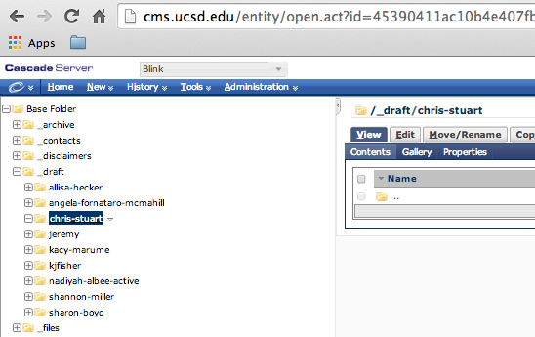

- Click on the New pull-down menu and select Page – Article.
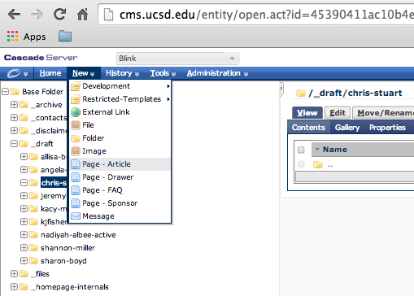

- The new article page template will appear:
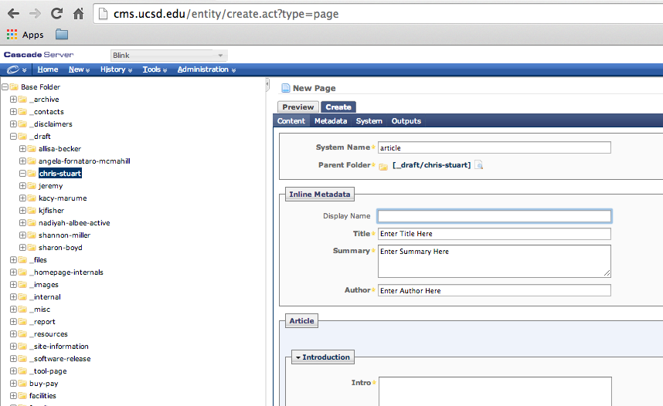
- Type in the System Name. This should be short, descriptive, and lowercase. You may use hyphens. For this exercise, type: disney. Check to make sure the Parent Folder is the one you want (for this exercise, it should be _draft/your-name).
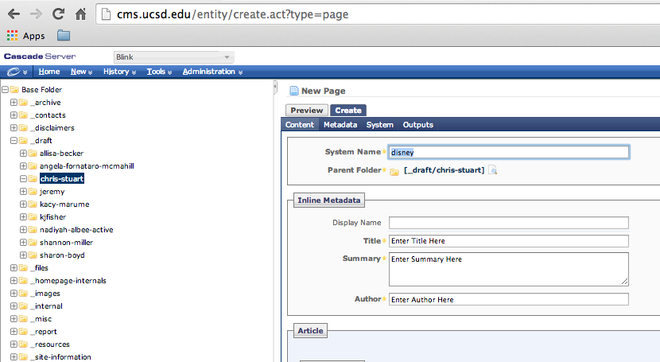

- Fill in these fields:
Display Name: Disney World
Title: I’m Going to Disney World!
Summary: Information on vacationing at Disney World.
Author: <Your Name>
Intro: Find information on vacationing at Disney World in Orlando, Florida.
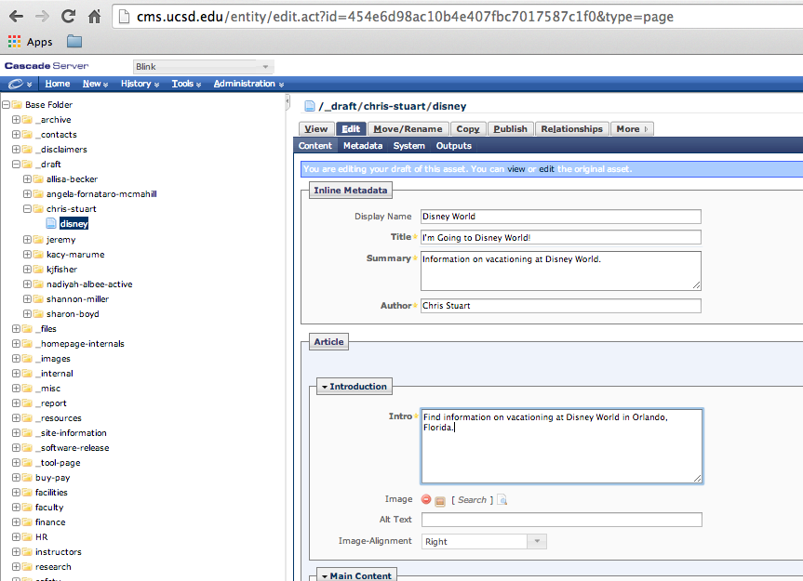
- Save the page by clicking the Submit button in the lower-right corner.
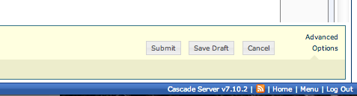
- You will now be back at the View tab.
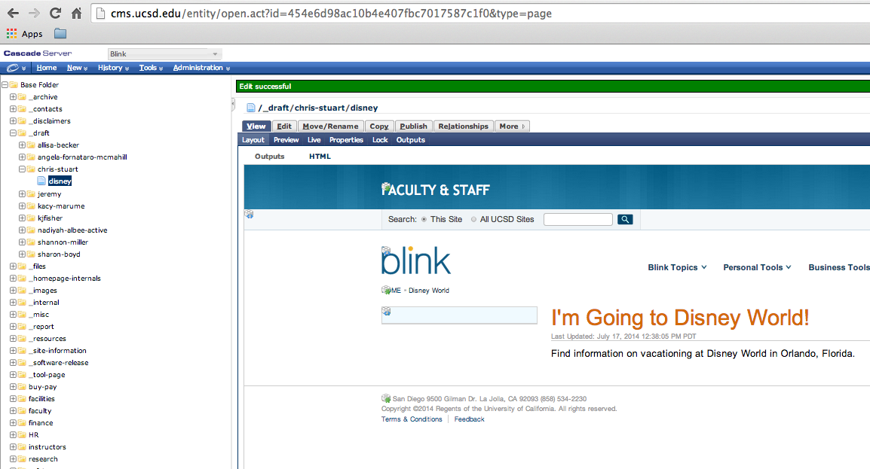
- To get back to editing the page, click the Edit tab.
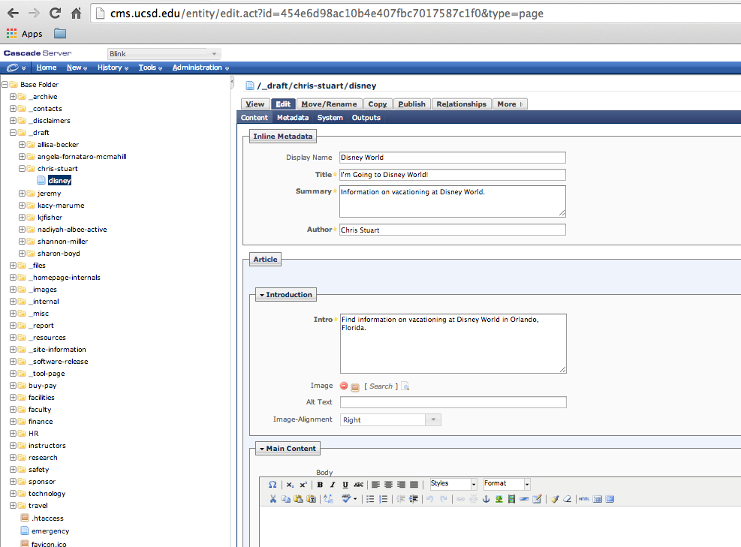
- Let’s add an image to the Introduction area. In the Image field, click on the word Search.
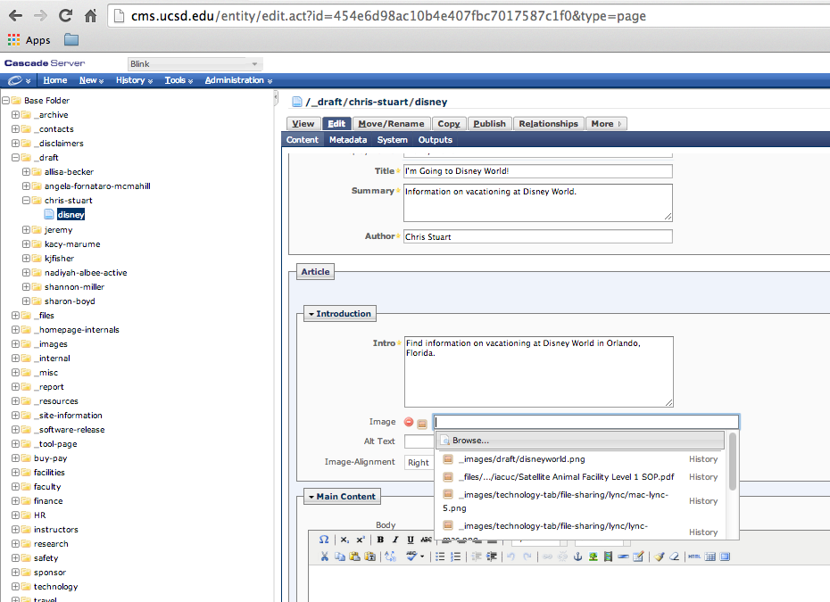
- Now Browse… to find the image file “disneyland.png” in _images/draft/disneyworld.png. Click the Confirm button.
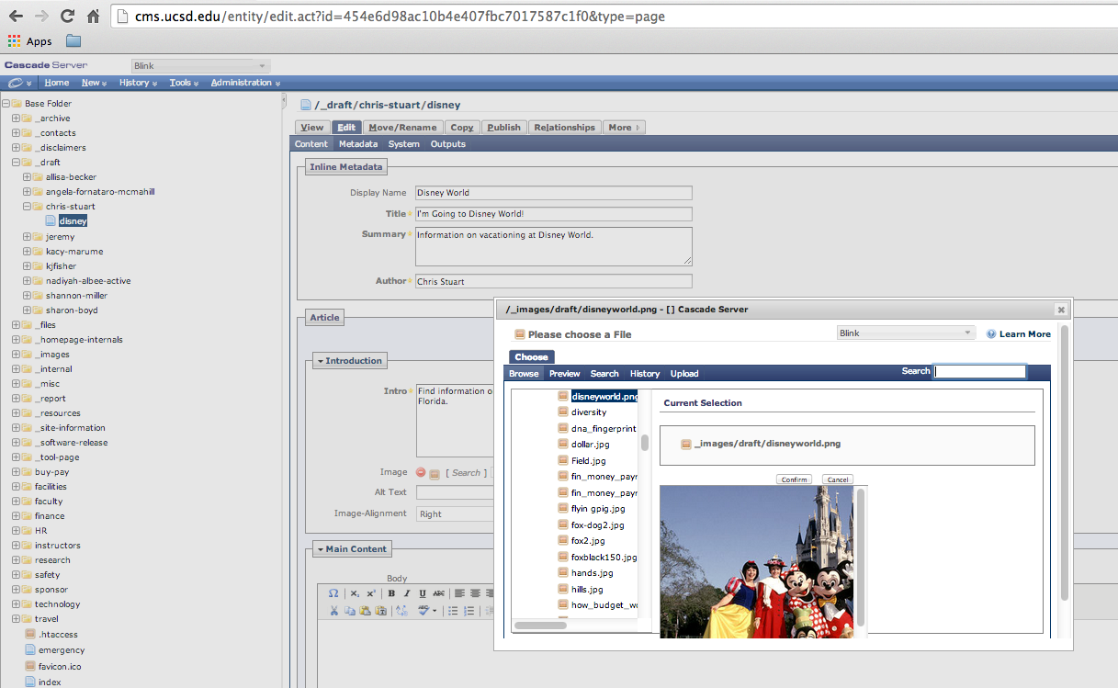
- Fill in the Alt Text field with “Disney World Castle”.
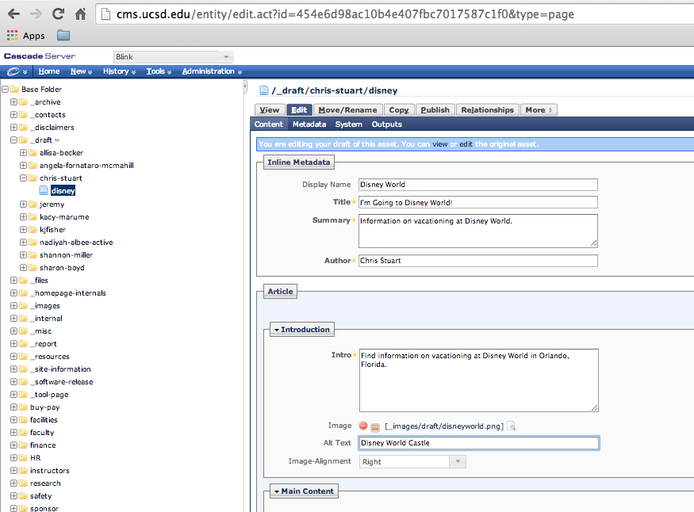
- Copy and paste the plain text below into the Main Content: Body field.

The Four Worlds of Disney
The most successful family entertainment and vacation spot ever created, now known as Disney World, started as 30,000 acres of central Florida swampland.
The park is really four major parks in one:
Magic Kingdom
EPCOT
Disney's MGM Studios
Disney's Animal Kingdom
It takes days, if not weeks and several vacations, to even begin to see everything at Disney World.
History of Walt Disney’s Dream
The precursor to Disney World was Disneyland, which opened in 1955 in Anaheim, California, and became the model of theme parks for an entire generation.
Filmmaker Walt Disney and his brother, Roy O. Disney, started plans in 1958 for something bigger in the East. The brothers visited Orlando, Florida, in 1964 and started buying land.
The Magic Kingdom and the Experimental Prototype Community of Tomorrow, EPCOT, were included in the plans for the new park. Disney World was opened in 1971, five years after Walt Disney’s death, but his dream lives on in the world’s largest and most successful theme park.
Tourism and Pricing
Over 15 million tourists visit the Magic Kingdom every year. Our park has a “Magic Your Way” plan and pricing structure. We encourage attendance at one of the four parks at a time, but we also offer ticket-hopper options that allow guests to visit several parks.
A family of four can plan on budgeting about $2000 to $4000 for a week’s stay in Disney World. Package deals can be found online and at travel agents, especially for off-season rates.
You may find that the busiest times at Disney World are whenever schools are out. Summer, holidays, and vacation times are the busiest and most costly.

- Your screen should now look something like this:
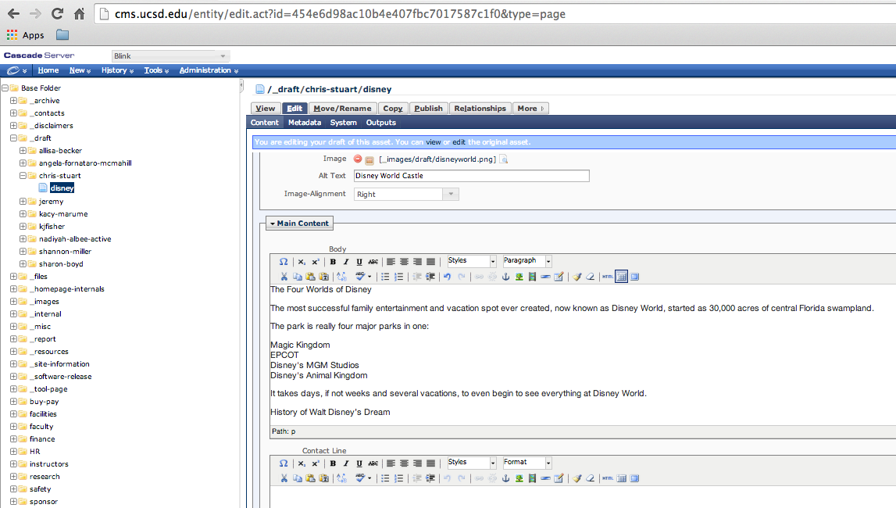
- Now let’s add a little formatting. Separately, highlight the three lines in the body content, and in the WYSIWYG editor make them each Heading 2.
The Four Worlds of Disney
History of Walt Disney’s Dream
Tourism and Pricing
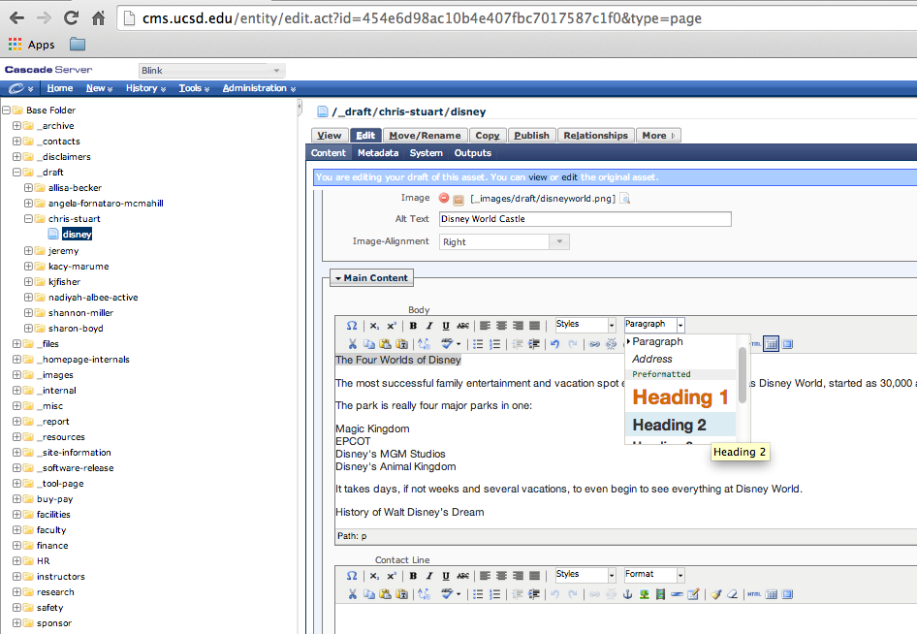
- In the body content field, make the four parks a bulleted list by selecting them and choosing the bullet-list icon in the WYSIWYG editor. So, they should look like this:
- Magic Kingdom
- EPCOT
- Disney's MGM Studios
- Disney's Animal Kingdom

- In the Contact Line field type in: Please contact Disney World at (555) 555-5555.
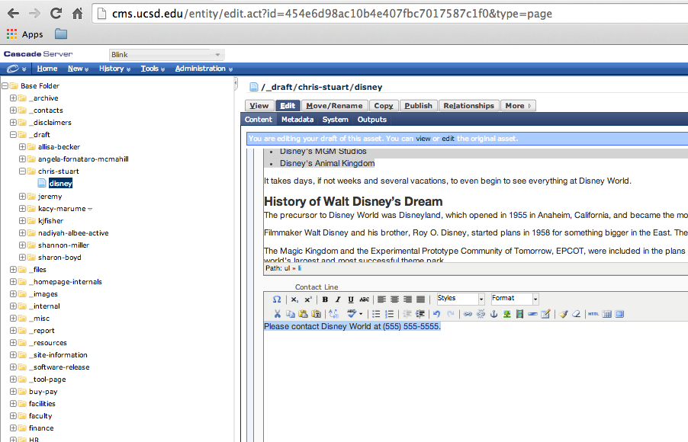
- Click the Submit button at the lower-right. You should now see something like this in the View tab:
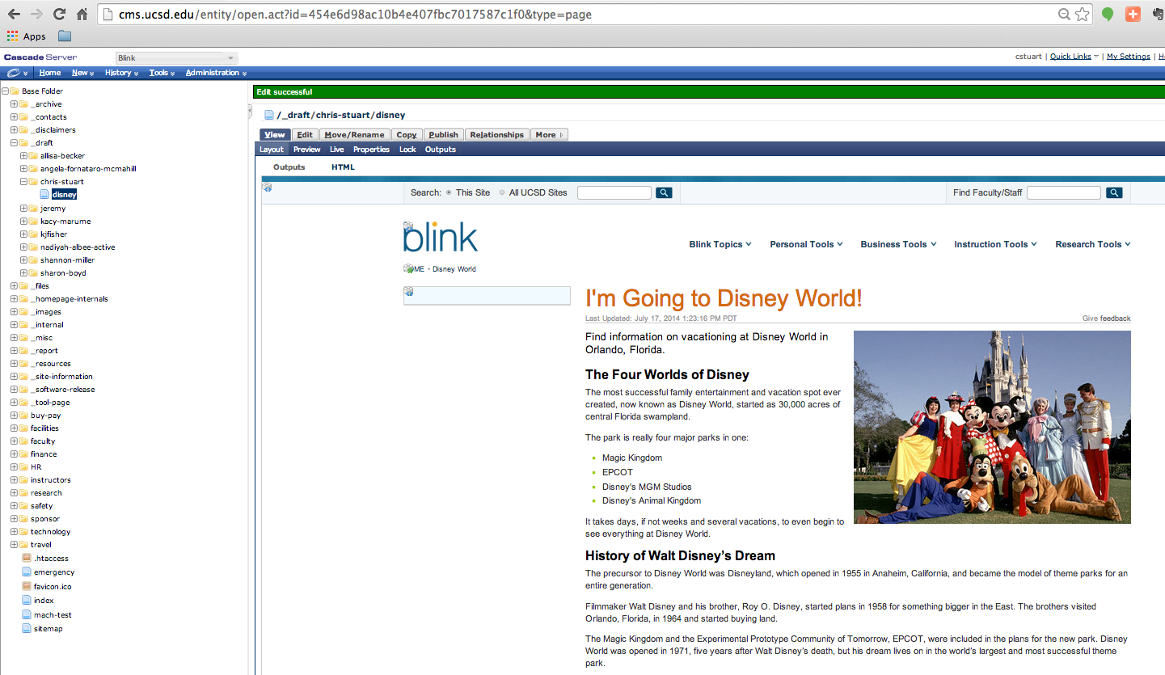
- You’ve now created the article page. It’s ready to be published.

