Blink training exercise 1:

Follow these instructions to create, add content, and publish an article page in the CMS.

- In the _draft folder, select the folder you created with your name:
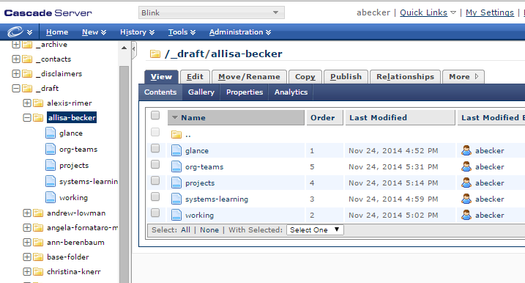

- Click on the New pull-down menu and select Page – Article.
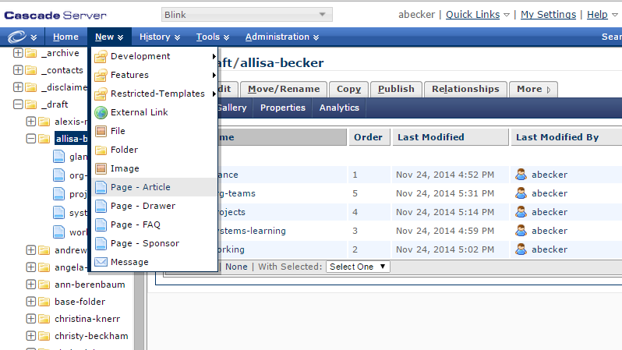

The new article page template will appear:
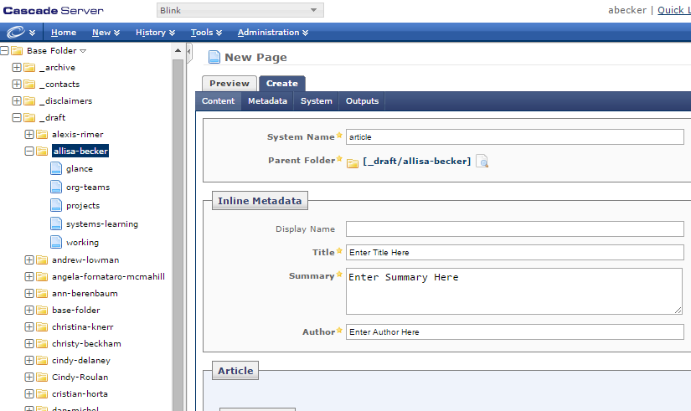

- Fill out the page Metadata:
  - Type in the System Name. This must be short, lowercase, and contain no spaces (use hyphens to connect words). Every folder needs 1 page named index. For this exercise, type: index.
  - Enter the Display Name. The display name is what shows up in the left-hand navigation and breadcrumb and should be short enough to avoid wrapping. For this exercise, type: San Diego Zoo.
  - The page Title shows up on the page in the big, orange font. For this exercise, type: The World Famous San Diego Zoo.
  - The Summary is what shows up in search results. Keep this to one sentence. For this exercise, enter: Learn about the world famous San Diego Zoo and Safari Park.
  - The Author is whoever is responsible for the page. For this exercise, type: <Your Name>
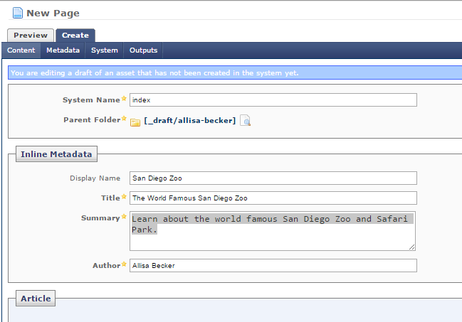

- Introduction section:
  - Put in a 1-sentence introduction in the Intro field. In this case, you can use the same text as the summary: Learn about the world famous San Diego Zoo and Safari Park.
  - We’ll add an image later.
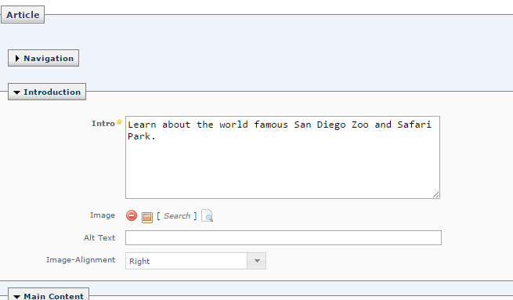

- Save the page by clicking the Submit button in the lower-right corner.
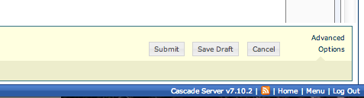

- You will now be back at the View tab:
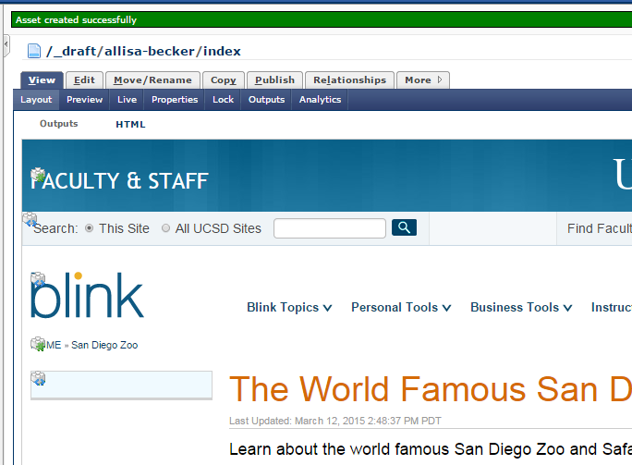
- To get back to editing the page, click the Edit tab.
- Copy and paste the plain text below into the Main Content: Body field.

San Diego Zoo Global is a not-for-profit organization that operates the San Diego Zoo, the San Diego Zoo Safari Park, and the San Diego Zoo Institute for Conservation Research. It was founded on October 2, 1916, by Harry M. Wegeforth, M.D, and has a 10-member Board of Trustees headed by Robert Horsman; Douglas G. Myers is our executive director.
San Diego Zoo
The 100-acre (40-hectare) Zoo is home to over 3,700 rare and endangered animals representing more than 650 species and subspecies, and a prominent botanical collection with more than 700,000 exotic plants. It is located just north of downtown San Diego in Balboa Park.
San Diego Zoo Safari Park
The Safari Park is an expansive wildlife sanctuary that is home to more than 2,600 animals representing more than 300 species. Its renowned botanical collection represents 3,500 species and 1.5 million specimens. Over half of the Park’s 1,800 acres (730 hectares) have been set aside as protected native species habitat. It is located 30 miles (48 kilometers) north of downtown San Diego in the San Pasqual Valley near Escondido, California.
Recent Honors and Awards
Association of Zoos and Aquariums' Edward H. Bean Award, 2014, African bush elephant program
American Association of Zoo Keepers' Certificate of Recognition 2014, Collaborative Learning Environment
Sustainable Environmental Enhancement Program of the Year, 2013, California Transportation Foundation

- Your screen should now look something like this:
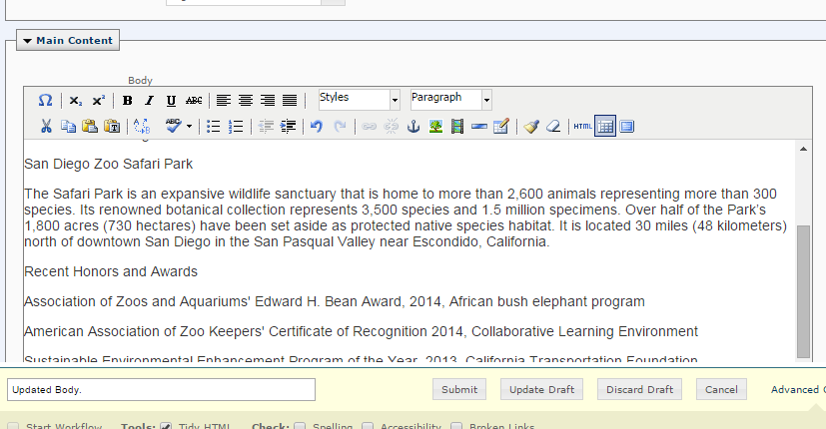

- Now let’s add a little formatting. Highlight each of the three headings in the body content, and select Heading 2 from the Format drop-down menu:
San Diego Zoo
San Diego Zoo Safari Park
Recent Honors and Awards

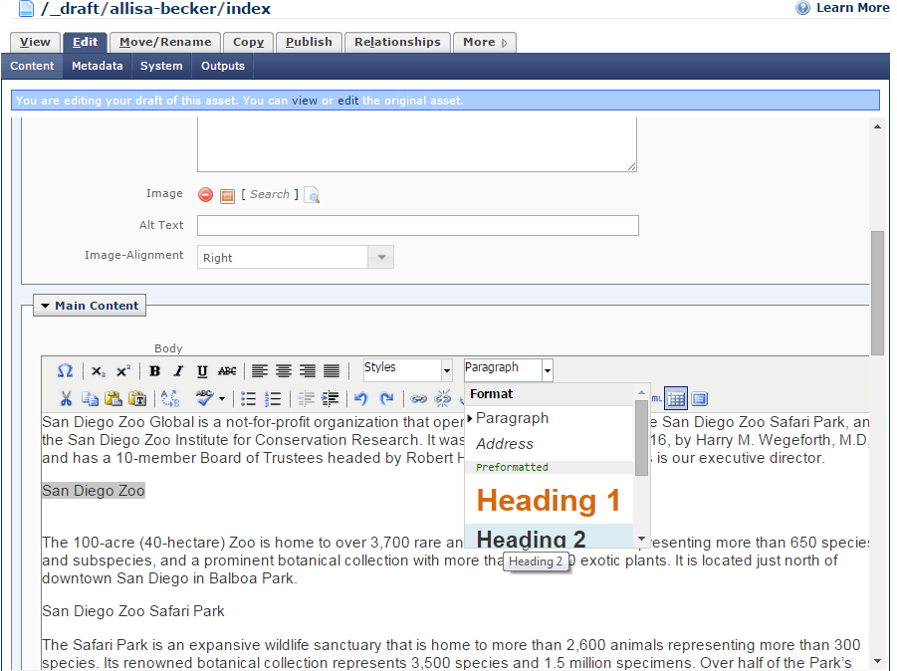

Scroll down to the Recent Honors and Awards section and make the 3 lines a bulleted list. Your content should now look like this:
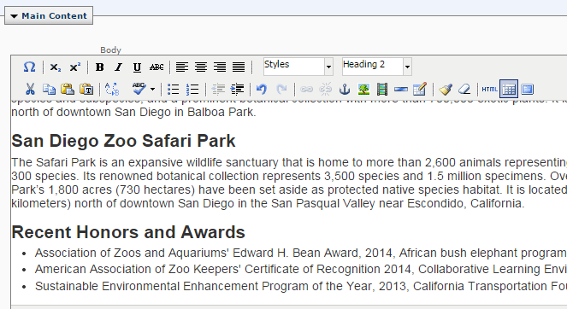
- In the Contact Line field type in: Questions? Contact us at (619) 231-1515.
- Click the Submit button to save the page.
- To publish the page:
  - Click the Publish tab.
  - Because this is a draft page, you just want to publish to the staging server. Uncheck the checkbox next to Web Server – Delivery.

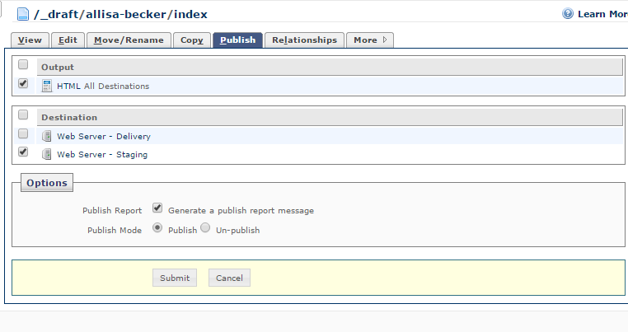
  - Click Submit.
- View the page on the staging server:
  - Bring up another browser tab and type in: http://stage-blink.ucsd.edu in the address bar.
  - Go back to the CMS tab and copy the breadcrumb from /_draft on and append that to the end of the URL.
  - Append .html on the end of the URL.
  - Ex: http://stage-blink.ucsd.edu/_draft/allisa-becker/index.html

