Add a Marker Exception in blink and in Self-Service

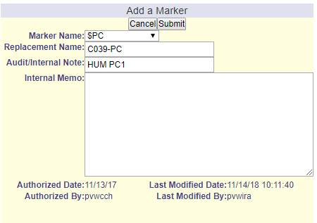
This exception type can be entered by clicking on the ‘Advanced Exceptions’ icon or by the menu navigation.
Select the appropriate value from the drop-down list and then enter the appropriate Replacement Name (pseudo course):
