Service Agreement Training Guide

To create your Service Agreement request, you will need access to Kuali Research. For detailed instructions on requesting access click on the following link: Requesting Kuali Access.
- Login into Kuali using your Business Systems ID or Active Directory login and password
- Click on Research Home
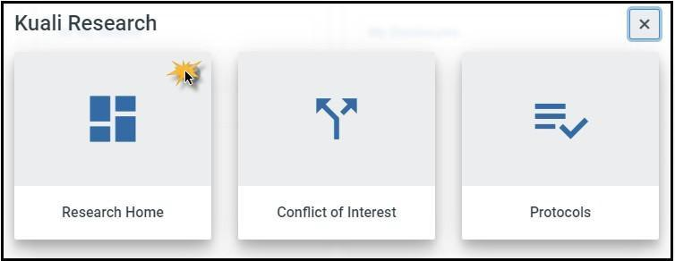

- From the left-hand navigation:
  - Click on Common Tasks
  - Click on Create Proposal in the Proposal Development Card
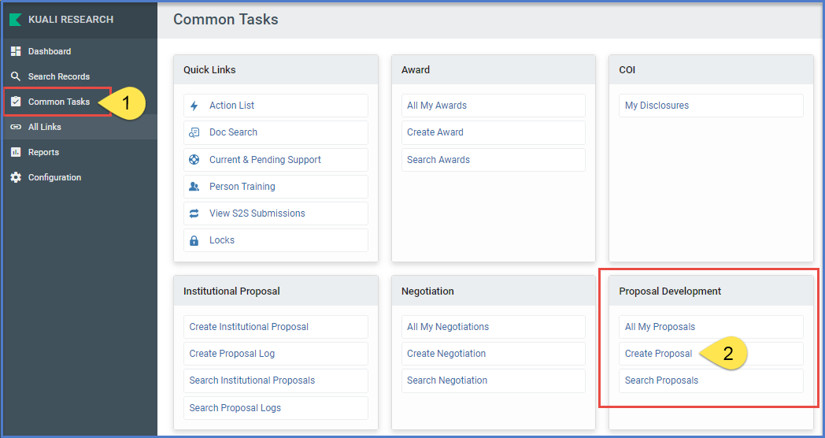

Create Proposal Screen

- Proposal Type: from the dropdown menu:
  - New (if it is a new agreement) or
  - Continuation (Amendment to an existing Service Agreement). An amendment is a change to any of the terms of an existing Service Agreement or an addition of time and/or money. The original Agreement and any prior amendments should be uploaded in the Attachments section of the KR record.
    - No other proposal types are applicable to Service Agreements

- Lead Unit: Select the Lead Unit from the dropdown menu. (You may have multiple options if you are a Department Research Administrator or proposal creator for more than 1 department)

- Activity Type: Select Other Sponsored Activities from the dropdown menu.

- Project Dates: Enter the project Start and End dates. The period of performance should be no longer than two years.

- Project Title: Enter the Project title.

  - Note in the title whether the customer has edited the UCSD template
  - If it’s an amendment, note the amendment number in the title

Example: Amd. 3 to Nissan Service Agreement, UCSD Template, No Edits

- In the Sponsor field, enter the external entity with which UCSD will be contracting (i.e. the other party on the agreement)
  - Start typing the name of the entity/sponsor directly into the field OR
  - Click on the magnifying glass at the end of the field and type in the name of the entity/sponsor in the Sponsor Name field using an asterisk* to narrow your search results (example: *Cornell*) and click on Search at the bottom of the Sponsor Lookup screen. All results with Cornell in the name will appear, allowing you to select the appropriate entity/sponsor.
  - If you’re unable to locate the entity/sponsor, you may need to request a new sponsor code be created. General campus departments should enter 9850 in the sponsor code field. After you have successfully entered the remaining information on the Create Proposal screen, navigate to the Attachments section, Notes tab and enter the name, physical address, and website address for the new entity, and save the PD record in progress. Do not yet route it. A notification will be sent to OCGA for a new sponsor to be created. Continue to work on creating the record in the meantime. SIO departments should contact SIO C&G 2-3 days in advance of routing to request a provisional sponsor code; if you don’t have time to do this please used 9850.

- Sponsor Deadline: Enter the date you are submitting the PD record.

- Sponsor Deadline Type: Select Internal from the dropdown menu

- Anticipated Agreement Type: Select Service Agreement from the dropdown menu

- Click Save and Continue at the bottom of the screen

Proposal Details Screen

The Service Agreement record has been saved, a proposal number has been created and you are now on the Proposal Details Screen. Verify the information you have entered

- After verifying the information, click Save at the bottom of the screen

- Navigate to the Key Personnel Screen

Key Personnel Screen

In this section you will assign the PI role to the Techincal Lead for the Service Agreement project. KR allows any UCSD employee to be listed as PI; as service agreements are not research, the Technical Lead does not need to be PI Eligible and a PI Exception is not required for this Agreement Type. This person will complete the COI disclosure as required. You will add all other UCSD personnel who will work on the project as Key Personnel; KR does not allow a Co-PI for this Agreement Type.

  - Click on Personnel under Key Personnel
  - Click on Add Personnel and enter the Last Name of the PI (best practice is to use the asterisk (*) to narrow your search results) and then click Continue
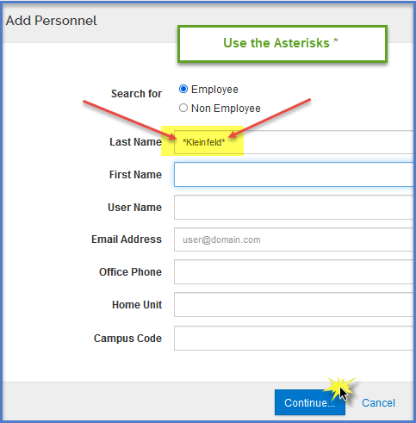

  - Click the radio button next to the appropriate person and click on Continue
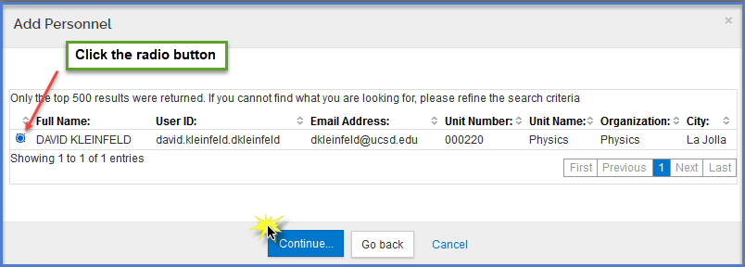

  - A pop-up to Assign a role will come up (Principal Investigator is pre-selected) – click on Add Person
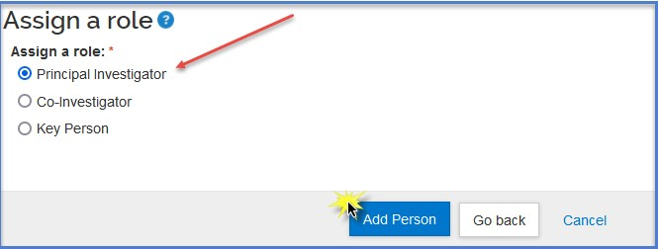

  - After you have added the PI, click on the blue “Notify” button next to the Principal Investigator’s name. This will send an electronic notification to the Principal Investigator to login to Kuali and answer the Compliance

Questionnaire

  - IMPORTANT NOTE - Your Technical Lead must either directly certify or provide answers for your certification on their behalf of the Service Agreement compliance questionnaire. These certification questions indicate to the reviewing officer that the Technical Lead has confirmed all of the record’s information and is certifying the accuracy of all information on the Kuali record you’re submitting. Aggregators may not certify on PIs’ behalf for other agreement types, but may do so for Service Agreements.

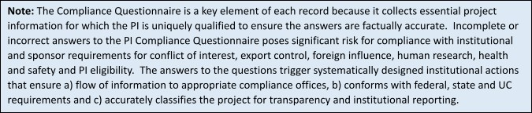

Questionnaire Screen

- Contact tab: Enter the full name and email address for the authorized official/legal contact for the sponsor/entity UCSD is negotiating with and click on Save.
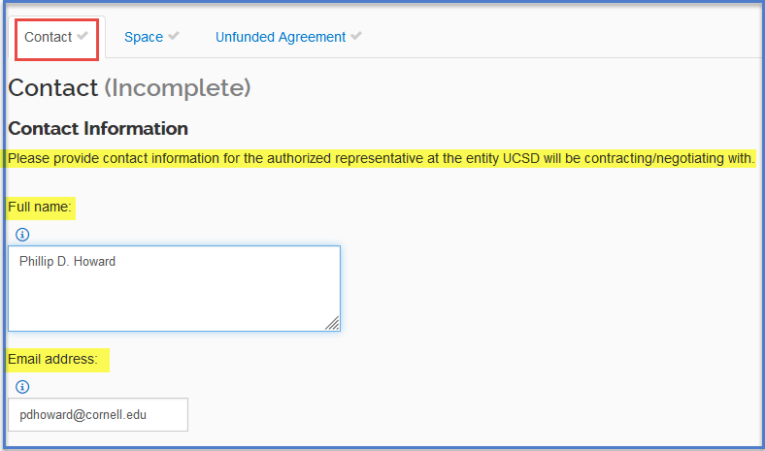

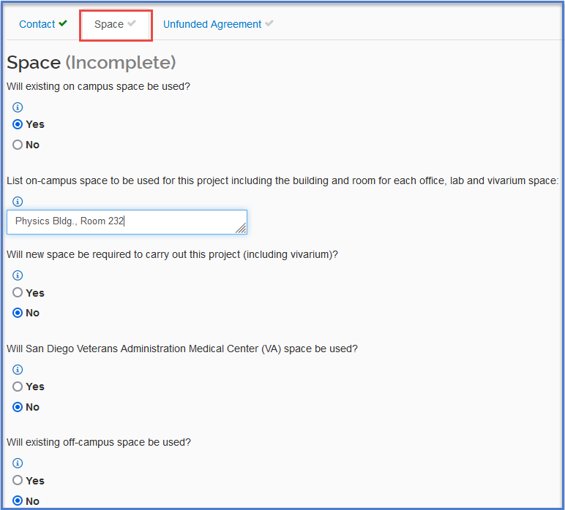
- Space tab: select yes or no to the questions regarding on-campus and off-campus space based on the needs of the Service Agreement.
- Service Agreement tab: In this tab you will answer additional questions relevant to your Service Agreement. Depending on the selections you make, additional questions will populate. Accurate responses will facilitate compliance routing and review.

Please note the Attestation: No post-acceptance/post-execution administration or compliance monitoring will be performed by Contracts and Grants, General Accounting, or Sponsored Project Finance.

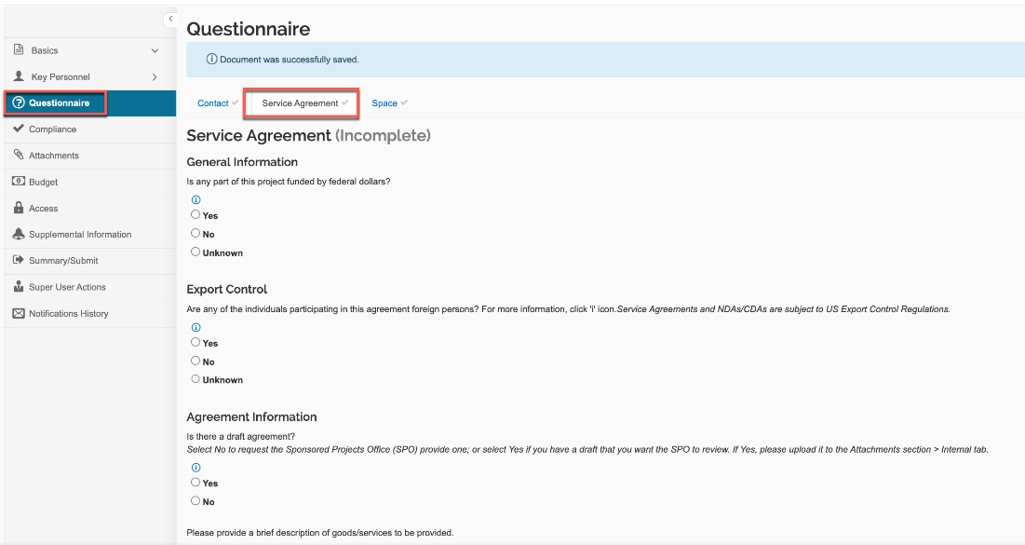

Compliance Screen

In this section, you will add a compliance entry for each compliance question responded to with “yes” in the PI Compliance Questionnaire answered by the Principal Investigator AND for any questions responded to in the Service Agreement Questionnaire, related to compliance. For example, if the PI answered yes to the Export Control questions, you will add a compliance entry for Export Control.
***Please note: An Export Control review line is no longer required for all Service Agreement PDs as a default – it is only required if the PI answers yes to an Export Control compliance question***
  - Click on Add compliance entry
  - Select the Type from the dropdown menu
  - Select the appropriate Approval Status from the dropdown menu. If the status is Pending, mark it Pending. If the Status is Approved, mark it Approved.
  - If available, add the OIA (IRB) and/or IACUC Protocol number. Add the Protocol number regardless of approval status.
  - Click on Add Entry
  - Click on Save and Continue

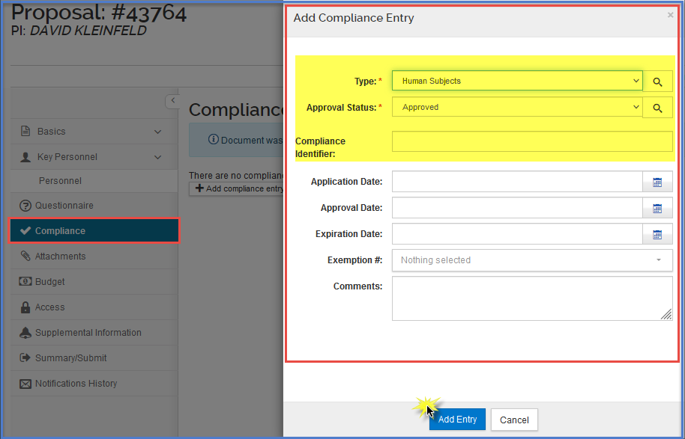

Attachments Screen

- Add attachments to the “Internal” tab
  - Ideally you will have a partially executed Service Agreement for OCGA countersignature as an attachment. Alternatively, you may have a redlined version of the UCSD template, or a draft of the customer’s own template.
  - If an amendment, include any prior iterations of the agreement
  - Include any other relevant documentation (e.g., related agreements, such as executed or pending contracts, grants, NDAs)
  - Include any correspondence with the customer or with internal compliance partners (eg, Export Control) that might facilitate OCGA review
  - Include any supporting compliance documentation
- In the Notes tab, include any information that might be helpful to OCGA in their review – context for the attachments, information on a needed timeline, a note that the customer would like OCGA to sign first, etc.
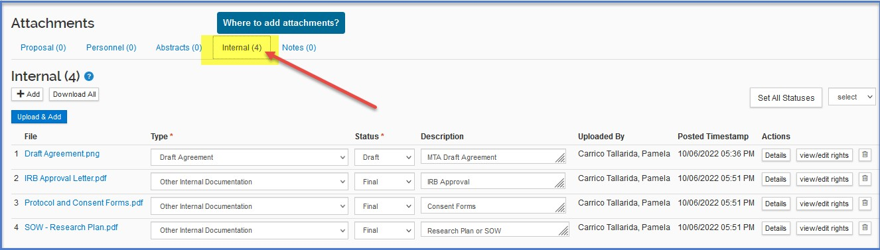

Budget Screen

Use the KR PD Budget tab to provide a Summary Budget of the project cost. All service agreements must assess Differential Income on all project costs. For more information on Differential Income, go to the Overview of Self Supporting Activities (SSA) Blink page. Do not upload the budget as an attachment.
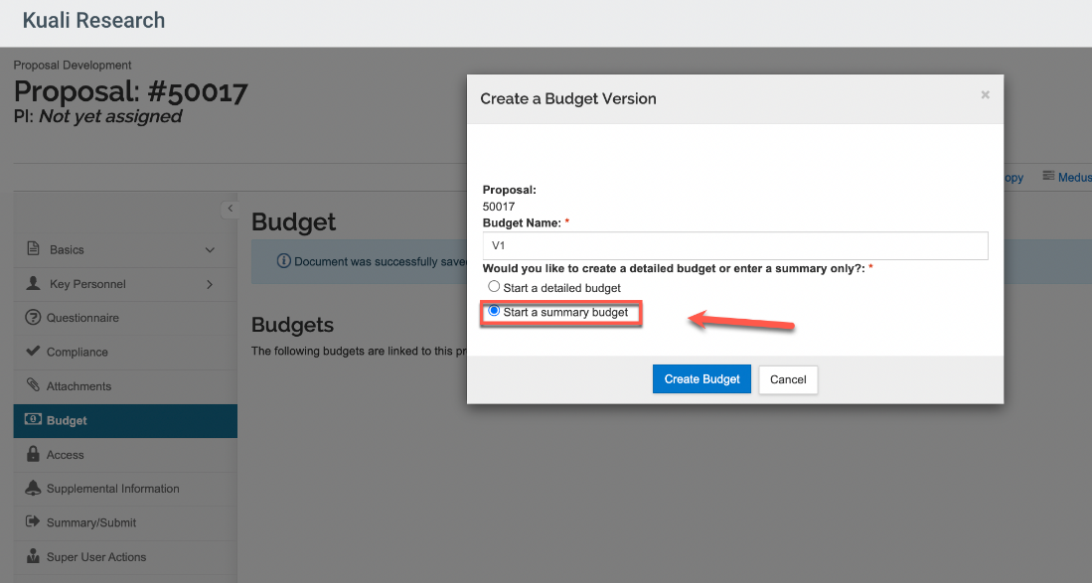

Departments are responsible for the operation of service agreement activities and for post-award financial management of agreements. Please contact your department business office if you have any questions about differential income or about the development of your service agreement budget.

Access Screen

No action is required, click Save and Continue

Supplemental Info Screen

Here you will enter your COA (Chart of Accounts) Financial Unit.
- Enter the COA Financial Unit
- Click Save and Continue

If you do not know your COA Financial Unit number:

- Click on the magnifying glass icon
- In the Account description field, enter your unit name (example: *physics*)
- Click on Search at the bottom of the screen
- Click on Select next to the appropriate name
- Click Save and Continue
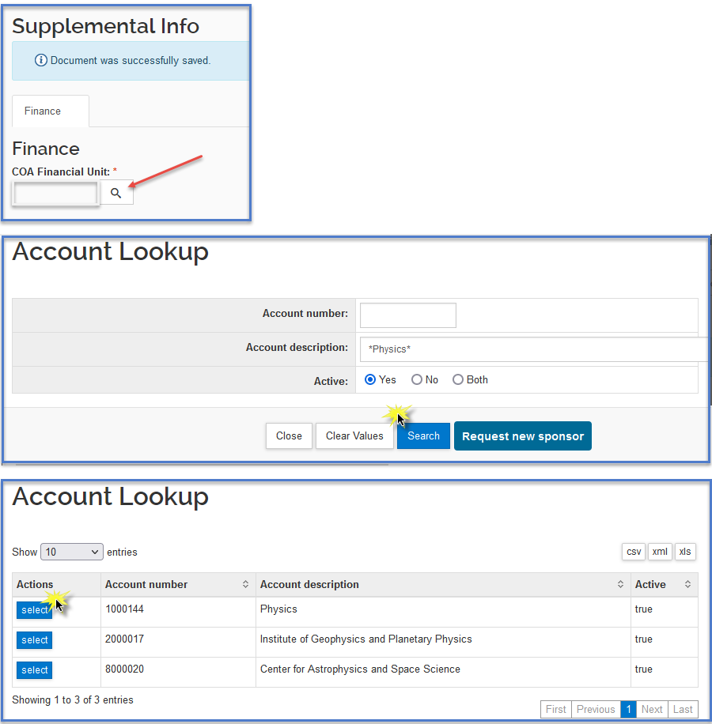

Summary/Submit Screen

- Click on Submit for Review

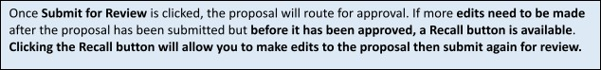

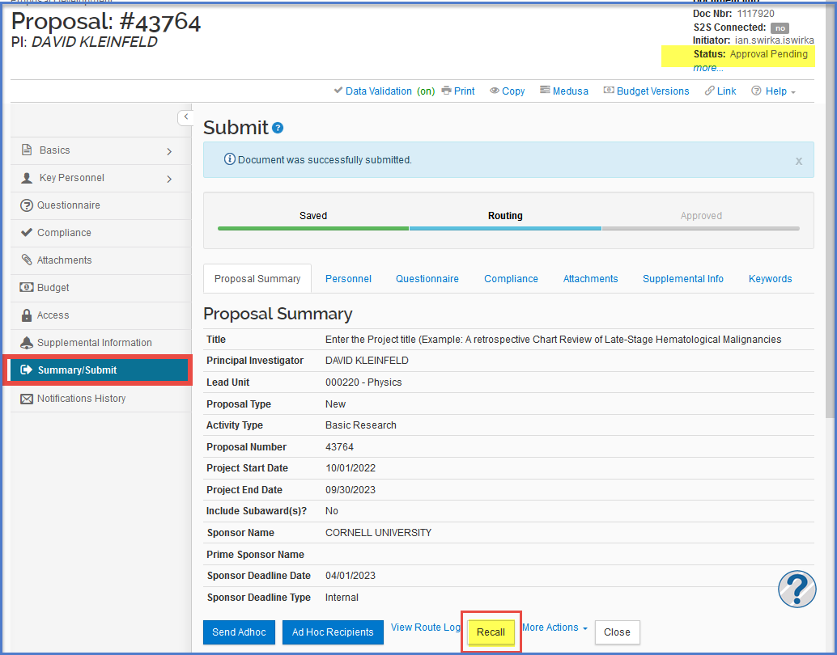

Notifications History

The Notifications History screen is where Kuali system generated notifications are listed, including the Principal Investigator certification notification. Each notification listed will note the Date Created, Recipients, Subject, and Message content.

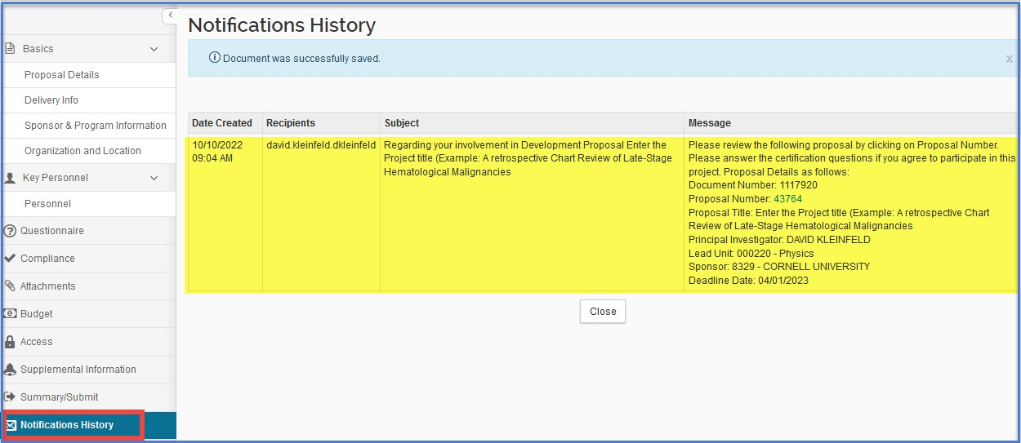

Kuali COI

- Conflict of Interest disclosures may be required by the Technical Lead for Service Agreements, depending on project details provided in the KR PD record and information provided by the PI in the Compliance Questionnaire. If Kuali COI determines that a disclosure is required, the Technical Lead will receive a system-generated notification.

