One Card Punch out Calibration Guide

- Turn the wheels to loosen the metal placement guides. Place the ID template on the punch out machine and move the metal plate’s until the head of the punch out machine aligns with blacked out outline on the ID template.

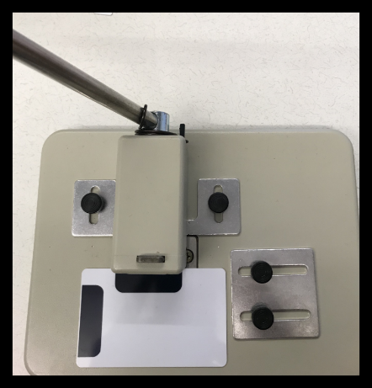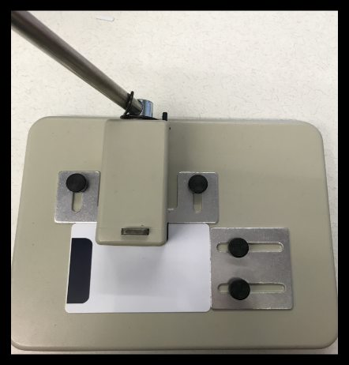

- After the head of the punch out machine is aligned, begin to slowly punch through the card. You should be able to punch though the hole with no problems if properly calibrated. If you feel any resistance stop and adjust the wheels to allow for a smooth punch through.

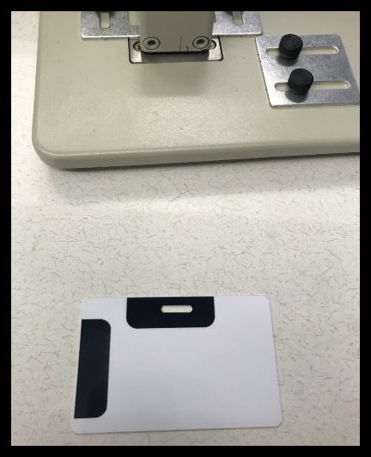

- For vertical punch outs, follow the same instructions to loosen and adjust the metal plates to the vertical outline on the template.
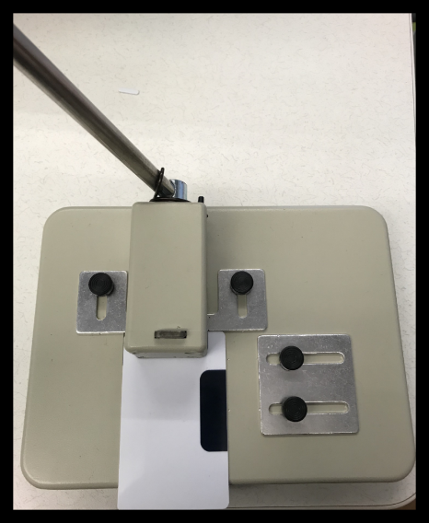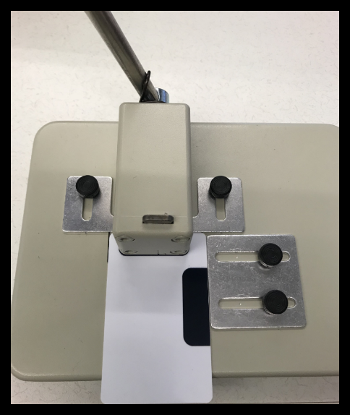

- Once the head of the punch out tool is matched up with the template and punching through the slot, the tool is ready to punch out One Card ID’s.

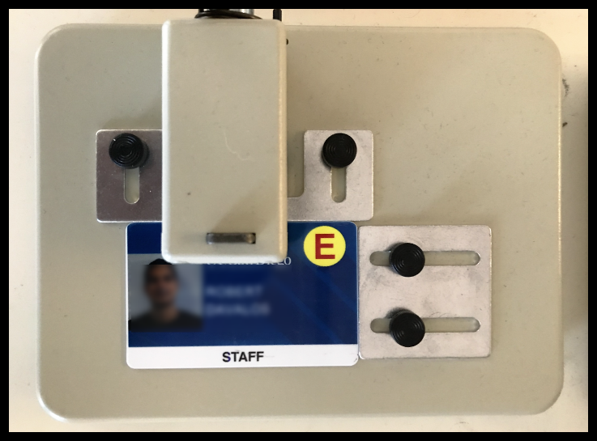

Datacard Table Top Slot Puncher
Mfg.Part: 3943-1510 | CDW Part: 1372395

Ensure punch out is punching through the hole in the template before testing on a new card as they will cost $20.00 to replace if punched through the antenna.

