Apply a Transfer Course in blink and in Self-Service

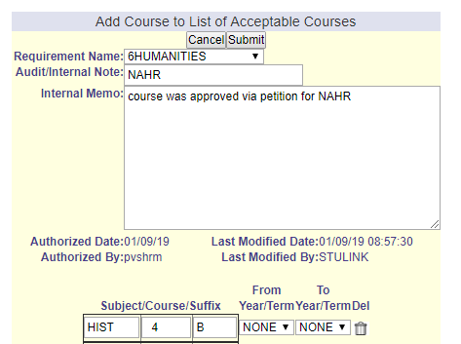
The ‘AC’ exception has historically been used to apply transfer course work to a student’s degree audit requirements.
When the ‘AC’ exception is created in blink, a ‘Modify Course’ (XC) is automatically created.
AC is identical to the ‘Add Course’ (AU) exception, and is not configured in the uAchieve Self-Service exceptions.
To accomplish the same action, the user will need to enter two separate exceptions: the ‘Modify Course’ (XC) and ‘Add Course’ AU:
