**How to upload a photo:**

1. Example of adding a photo entry on the website:
   1. Click on the “Add An Entry” button
      1. 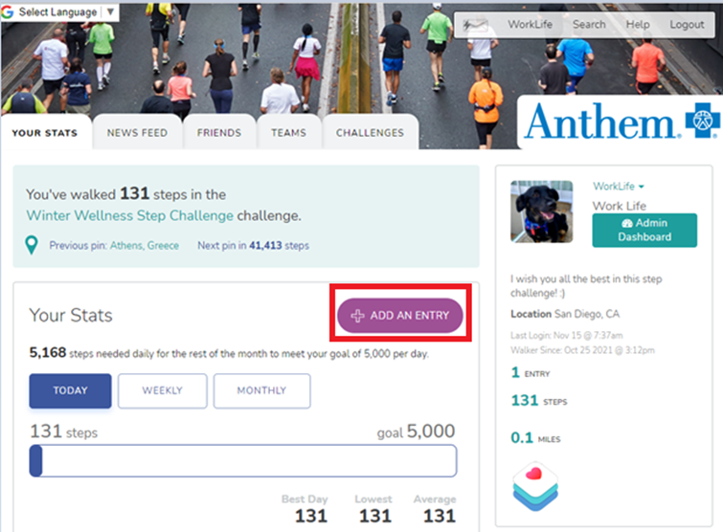
   2. Next
      1. Click on the “Upload Photo” button
      2. Select “Anyone” from the drop-down list,
      3. Click the “Update Entry” button
         1. 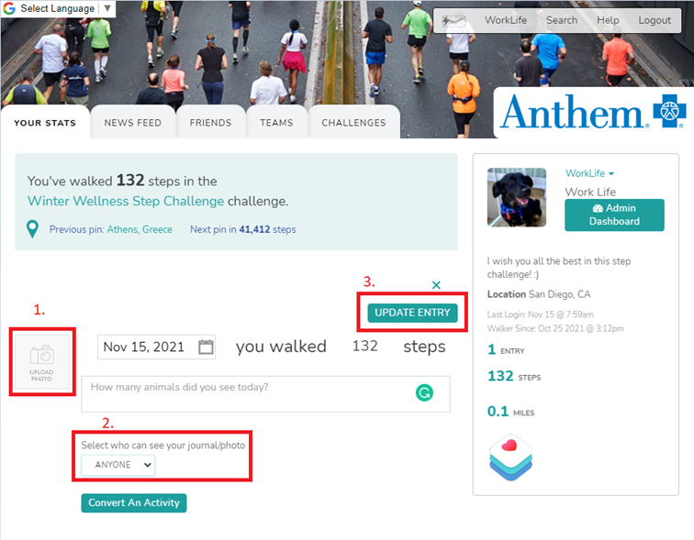
2. Example of adding a photo entry on the Apple/iOS app:
   1. Click on the circular button on the bottom right with a plus sign on the shoe cid:image016.png@01D7DA01.5A718310
      1. 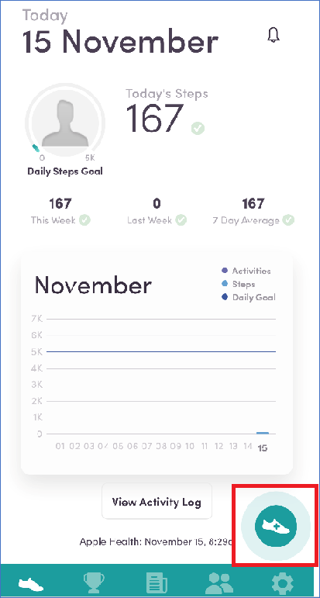
   2. Next
      1. Click on the orange eyeball icon cid:image025.png@01D7DA01.5A718310, and change the privacy setting to “Public”
      2. Then click on the yellow photo button cid:image027.png@01D7DA01.5A718310 and select the photo you want to upload for the challenge
      3. The photo you upload will show up in the small photo circle next to the words “How did your day go?”
      4. When you are done uploading your photo, click on the X button on the top right of your screen. Unfortunately, there is no submit button.
      5. 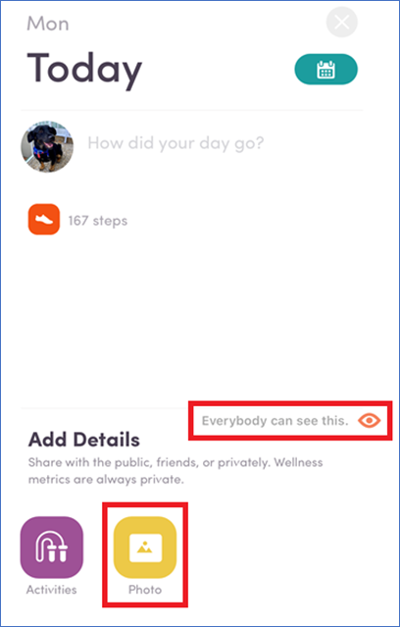
   3. Ensure that you have successfully uploaded your photo by viewing the Newsfeed
      1. On the website, it will look like this
         1. 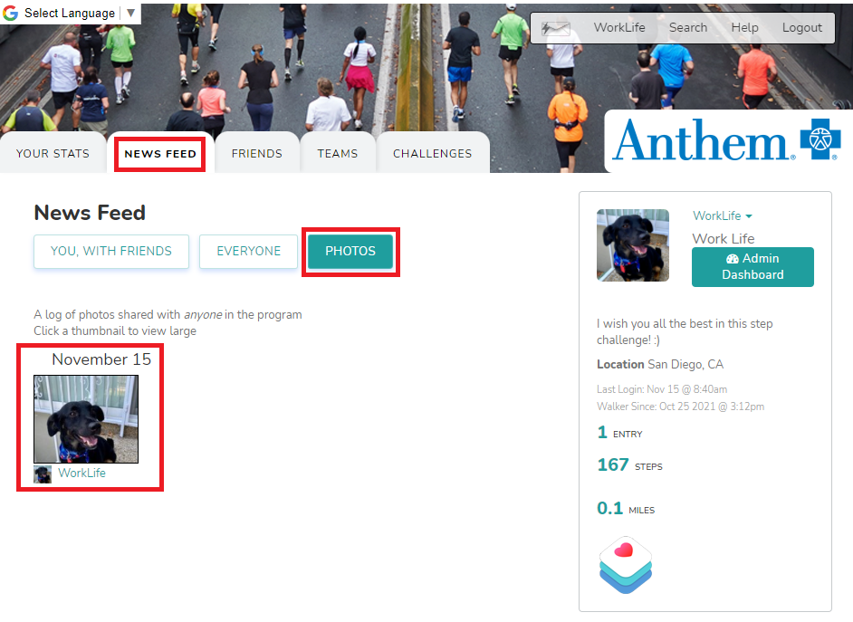
      2. On the iOS app, it will look like this. First, click on the Newsfeed icon at the bottom center of the app cid:image032.png@01D7DA01.5A718310
         1. 