OFFICE OF RESEARCH AFFAIRS
9500 GILMAN DRIVE, MC 0043
LA JOLLA, CALIFORNIA 92093-0043
TEL: (858) 534-3526
EMAIL: VCRESEARCH@UCSD.EDU
URL: RESEARCH.UCSD.EDU

DEPARTMENT OF PSYCHOLOGY
MCGILL HALL
9500 GILMAN DRIVE, MC 0109
LA JOLLA, CA 92093-0109
OFFICE: 858-822-1887
E-MAIL: SANDRABROWN@UCSD.EDU

DEPARTMENT OF PSYCHIATRY
UC SAN DIEGO SCHOOL OF MEDICINE
9500 GILMAN DRIVE , MC 0603
LA JOLLA, CA. 92093-0603
OFFICE: 858-552-7563
E-MAIL: SANDRABROWN@UCSD.EDU

DATE

Reference information:

To: (Agency info – fill in as needed)

PI: (PI name – fill in as needed)
Application Title: (fill in as needed)
NIH Grant Number: (fill in as needed)
UCSD Proposal Number: (fill in as needed)
FOA: (fill in as needed)
Time frame: (fill in as needed)

To whom it may concern:

On behalf of the University of California San Diego, I am pleased to provide this letter of institutional support for the application of the above-referenced investigator. UC San Diego is committed to allowing COVID-19 related research, (basic, translational, and/or clinical) to proceed, and the investigator is committed to conducting the research during the time frame as referenced above.

Further information regarding UC San Diego’s Continuity of Research efforts can be found by accessing the following link: https://blink.ucsd.edu/research/covid-19/index.html

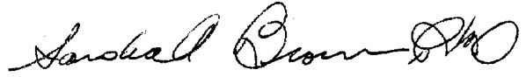
Sincerely,

Sandra A. Brown, Ph.D.
Vice Chancellor for Research
Distinguished Professor of Psychology and Psychiatry
University of California San Diego

