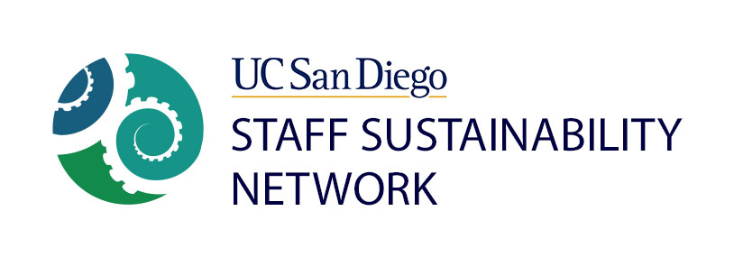
Staff Sustainability Network Staff Project Grant Review Panel Details and Timeline
Grant Review Panelist Selection and Duties:
The grant review panel will consist of two Executive Board Members (selected by Executive Board consensus) and three dues-paid members. These five individuals cannot be applicants to the grant program during the current cycle.
Review Process:
The five panelists will receive all applications from the two selected Executive Board members, along with a criteria evaluation matrix sheet by February 25th. Five panelists will meet (for approximately one hour or less) and come to a determination on the awardee(s).
Timeline (2016-2017):
ASAP: Ali/Jen finalize review criteria and other proposal details.
Jan. 20th – Ali/Jen send final draft of Application and Ariel uploads to website.
Jan. 21st – Ali/Jen announce Staff Project Grant at General Meeting, explaining details, review criteria, review process, and timeline. Ali/Jen also request members to volunteer to serve as review panelists.
Feb. 11th – Deadline: Applicants must send an email of intent (Subject line: SSN Staff Project) to Recording Secretary Kim Kane and Ali Sanchirico by EOB this day stating the following: 1) Title of project 2) Name(s) of applicant(s), and 3) department(s) of applicant(s).
Feb. 17th – Deadline: Applicants must send an email with completed Application attached to Kim and Ali by EOB this day.
Feb. 18th – Applicants must give less-than-five minute presentation to the General Meeting audience.
Feb 23rd – Executive Board selects five member Review Panel.
Feb 25th – Selected Executive Board members organize meeting of the Review Panel during the week of February 29-March 4 to discuss the applications and pick the successful applicant(s).
March 14th – Awardee(s) notified and any budgets negotiated. (Non-funded applicants also notified.)
March 17th – Awardee(s) announced at General Meeting
June 30th, 2017 – Project end date. All spending must be concluded.
July 31st, 2017 – Final report due.
August, 2017 – Project teams give presentation to SSN meeting to highlight their accomplishments.

